**Cloud-hosted Banking Data Analytics and Reporting System on AWS**

"CloudBank Analytics" is a comprehensive cloud-based banking data analytics and reporting system designed to streamline financial data processing, analysis, and visualization. The project leverages Amazon Web Services (AWS) for robust and scalable infrastructure, utilizing Amazon RDS for secure and efficient data storage, AWS Elastic Beanstalk for reliable web application hosting, and AWS Lambda for automated data processing and report generation.

The user-friendly web interface, built with Flask, allows bank administrators to log in to their personal accounts, creating a seamless experience for data visualization and report management. Once logged in, users are presented with a dashboard that serves as a central hub for all banking analytics activities. The dashboard prominently features real-time financial data, key performance indicators (KPIs), and options for generating custom reports.

By combining modern cloud technology with an intuitive user interface, "CloudBank Analytics" aims to provide financial institutions with powerful tools for monitoring customer behavior, managing risk, and ensuring regulatory compliance, ultimately improving decision-making and operational efficiency.

## **Scenarios**

### **Scenario 1: Real-time Transaction Monitoring**

Sarah, a bank's fraud detection analyst, logs into CloudBank Analytics during her morning routine. The dashboard immediately alerts her to unusual transaction patterns detected overnight. Using the real-time analytics feature, Sarah quickly investigates the flagged transactions, confirms a potential fraud attempt, and takes immediate action to protect the affected accounts.

### **Scenario 2: Custom Report Generation**

John, a financial manager, needs to prepare a comprehensive quarterly report for the board meeting. He logs into CloudBank Analytics and uses the custom report generation feature. John selects various metrics such as loan performance, deposit growth, and customer acquisition rates. The system, leveraging AWS Lambda, quickly processes the vast amount of data stored in Amazon RDS and generates a detailed report, which is then stored in Amazon S3 for easy access and sharing.

### **Scenario 3: Regulatory Compliance Monitoring**

Lisa, a compliance officer, uses CloudBank Analytics to ensure the bank meets all regulatory requirements. She accesses a specialized dashboard that tracks key compliance metrics in real-time. When she notices that a particular metric is approaching a regulatory threshold, she uses the system to drill down into the underlying data, identify the root cause, and initiate corrective actions before any compliance issues arise.

**Architecture:**

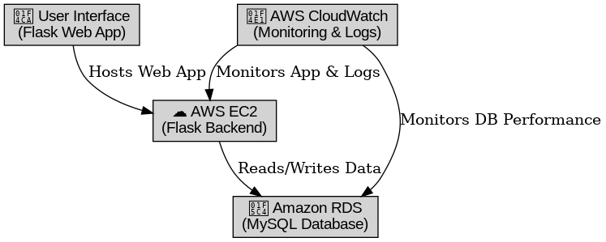

**ER Diagram:**

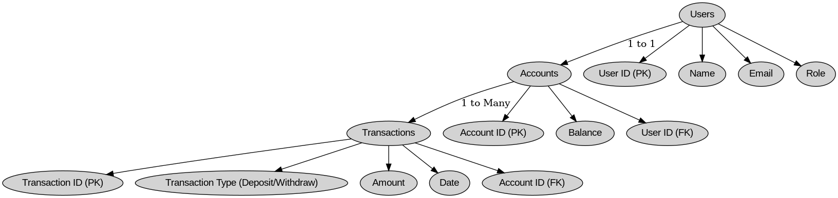

#### **Pre-requisites:**

1. AWS Account Setup: [https://youtu.be/CjKhQoYeR4Q?si=ui8Bvk_M4FfVM-D](https://youtu.be/CjKhQoYeR4Q?si=ui8Bvk_M4FfVM-Dh)h

2.Web Application Stack : [FLask](https://www.youtube.com/results?search_query=flask+tutorial) || [MySQL Connector using flask](https://www.youtube.com/results?search_query=mysql+connector+for+flask) || [HTML/JS/CSS](https://www.youtube.com/results?search_query=html+js+css+tutorial+)

3. AWS EC2 Instance: <https://www.youtube.com/results?search_query=aws+ec2+oneshot>

4. RDS Database: <https://www.youtube.com/results?search_query=rds+oneshot>

5. MySQL: <https://www.youtube.com/results?search_query=mysql+tutorial>

6. RDS to MySQL:<https://www.youtube.com/results?search_query=mysql+connector+for+rds>

7. Clone Git repo: <https://www.youtube.com/results?search_query=clone+github+repository>

8. AWS Cost Management: <https://youtu.be/OKYJCHHSWb4?si=aY3DQl1v26CfZxXA>

9. AWS IAM: <https://www.youtube.com/results?search_query=aws+iam>

10. AWS CloudWatch:<https://www.youtube.com/results?search_query=aws+cloudwatch>

#### **Project Flow:**

## **1. AWS Account Setup**

* Create an AWS account and configure billing settings.
* Create IAM users and user groups if required.
* Access the AWS Management Console to set up services.

## **2. RDS Database Setup**

* Create an Amazon RDS instance using MySQL.
* Configure database security, set up credentials, and define a schema for BloodBridge.
* Tables Creation:
  + users(Donors & Recipients)
  + blood_requests(Track blood needs)
  + donations(Record donor contributions)

## **3. MySQL Database Configuration**

* Set up MySQL on the RDS instance.
* Configure tables for users, blood requests, and donations.
* Implement queries for operations like request creation, donor registration, and tracking donations.

## **4. EC2 Instance Launch**

* Launch an AWS EC2 instance to host the BloodBridge platform.
* Configure security groups to allow HTTP/HTTPS traffic.
* Connect EC2 to RDS for database access.
* Deploy the Flask application on EC2.

## **5. Flask Backend Development**

* Integrate Flask with the MySQL database on RDS.
* Implement API endpoints for:
  + User registration & authentication
  + Blood request creation & tracking
  + Donor registration & matching

## **6. HTML & CSS Frontend Development**

* Develop an interactive UI using HTML, CSS, and JavaScript.
* Design pages for:
  + User registration & login
  + Blood request submission & tracking
  + Donor registration & matching system
* Connect the frontend to Flask backend for real-time updates.

## **8. Monitoring & Maintenance**

* Use AWS CloudWatch to monitor:
  + EC2 performance & traffic
  + RDS database queries & storage
* Set up alerts for system performance & database health.

## **Milestone 1: AWS Account Creation**

In this milestone, we will set up an AWS account to access the necessary services for the BloodBridge project.

**Activity 1: Create AWS Account**

1. Go to the AWS website.

2. Click on the "Create an AWS Account" button.

3. Follow the prompts to enter your email address and choose a password.

4. Provide the required account information, including your name, address, and phone number.

5. Enter your payment information. (Note: While AWS offers a free tier, a credit card is required for verification.)

6. Complete the identity verification process.

7. Choose a support plan (the basic plan is free and sufficient for starting).

8. Sign in to your new AWS account.

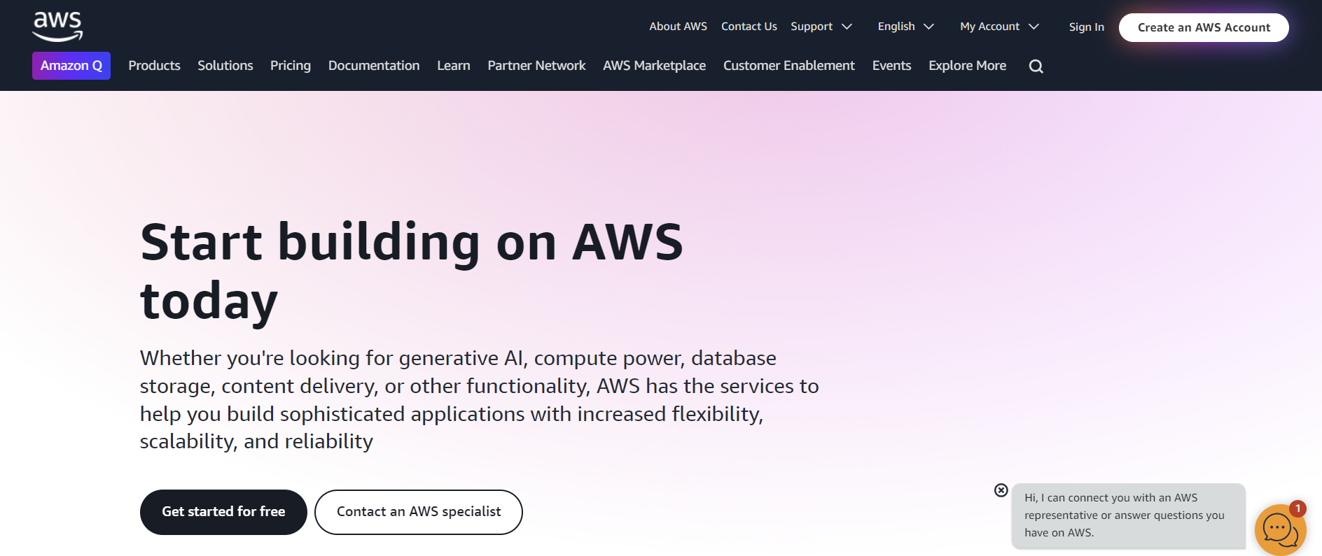

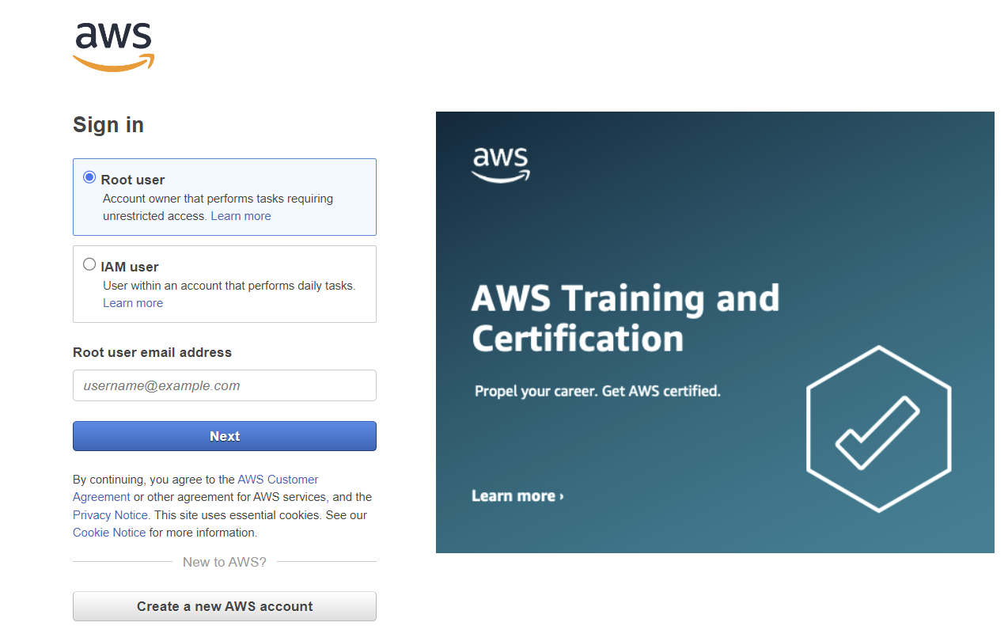

**Activity 2: Set Up IAM Users and Permissions**

1. Access the IAM console from the AWS Management Console.

2. Create a new IAM user for yourself with administrative access.

3. Set up multi-factor authentication (MFA) for added security.

4. Create a group for developers and assign necessary permissions.

5. Generate access keys for programmatic access if needed.

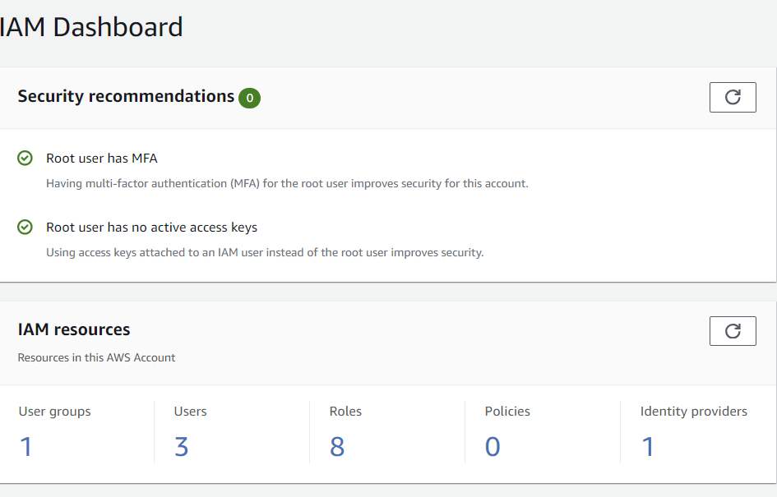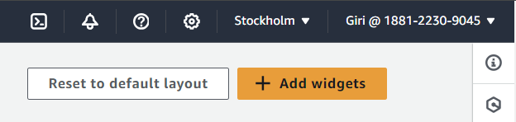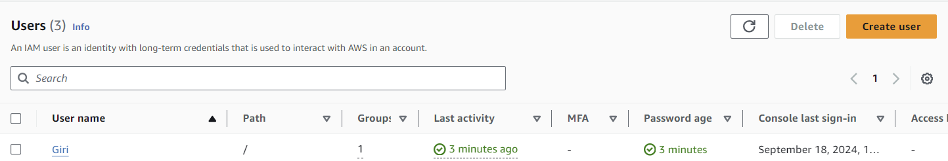

#### **Milestone 2: RDS Database Creation and Setup**

### **Activity 1: Create Amazon RDS Instance**

1. Access RDS Console from the AWS Management Console.
2. Create a new RDS instance:
   * Choose MySQL as the engine type.
   * Select an appropriate instance size (e.g., db.t3.micro for testing).
   * Configure storage, network settings, and security groups.
   * Set up the master username and password.
   * Make sure to allow connections from your local IP for development and testing.
3. Note down the endpoint, port, database name, username, and password.
4. **Activity 2.1: Create an RDS Instance**
   * Choose the RDS service from the AWS Management Console.

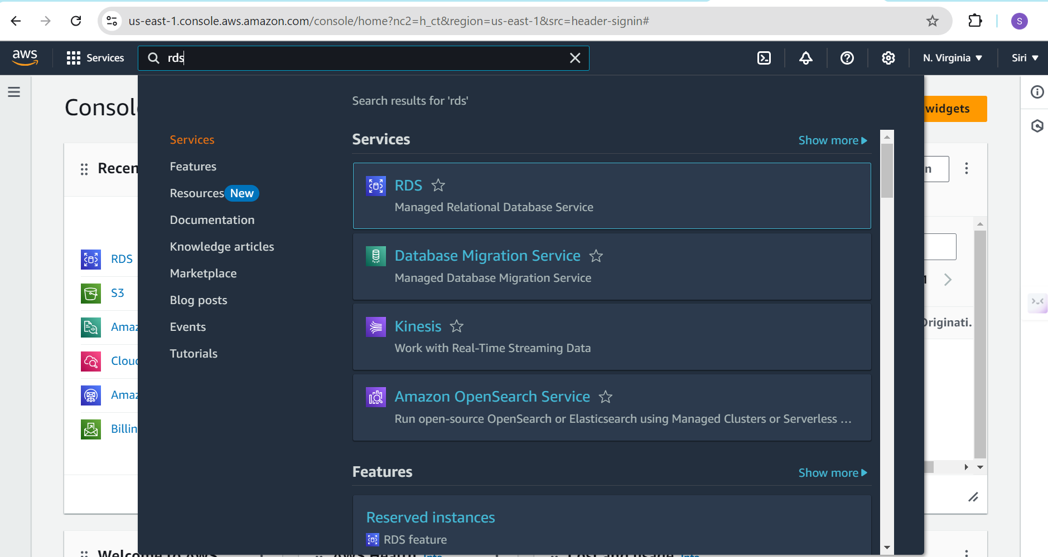

* The RDS interface

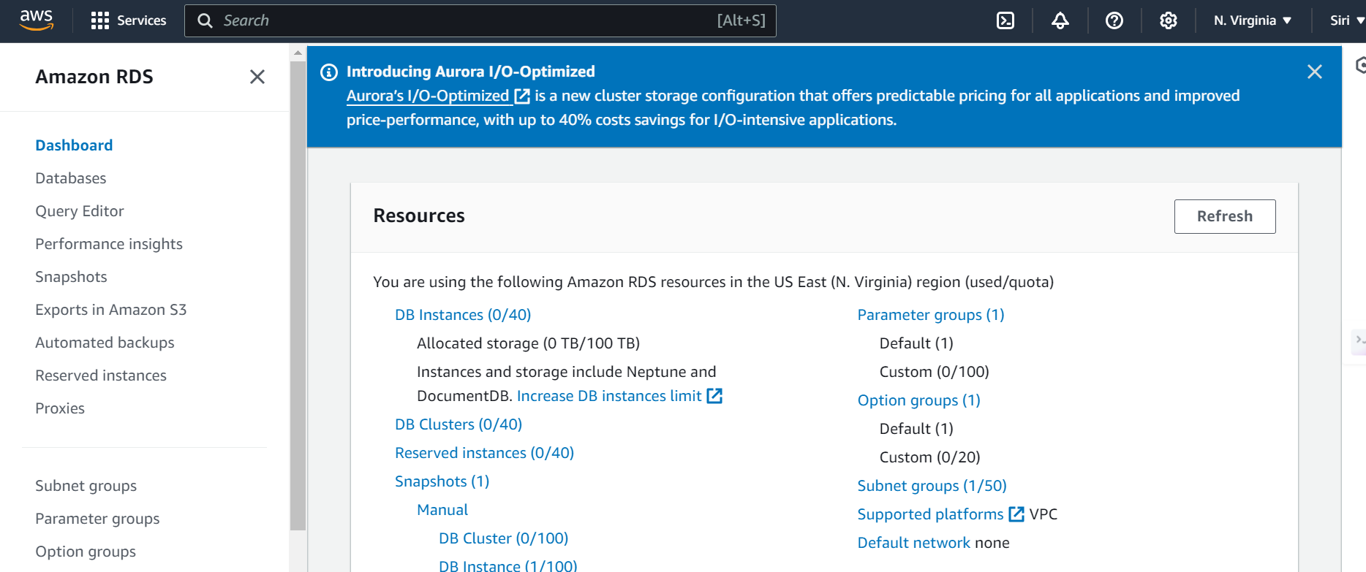

* Click on create database

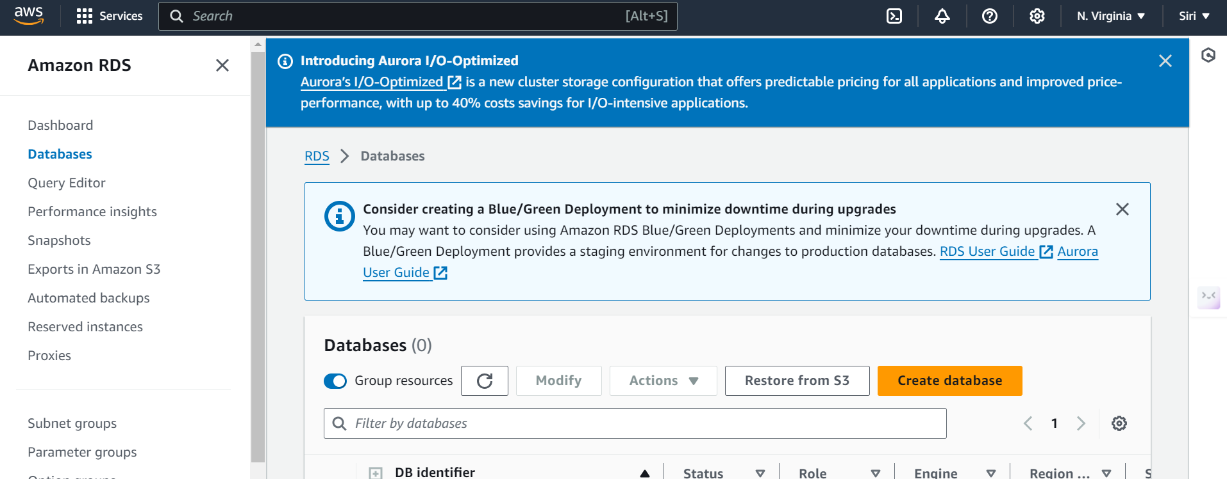

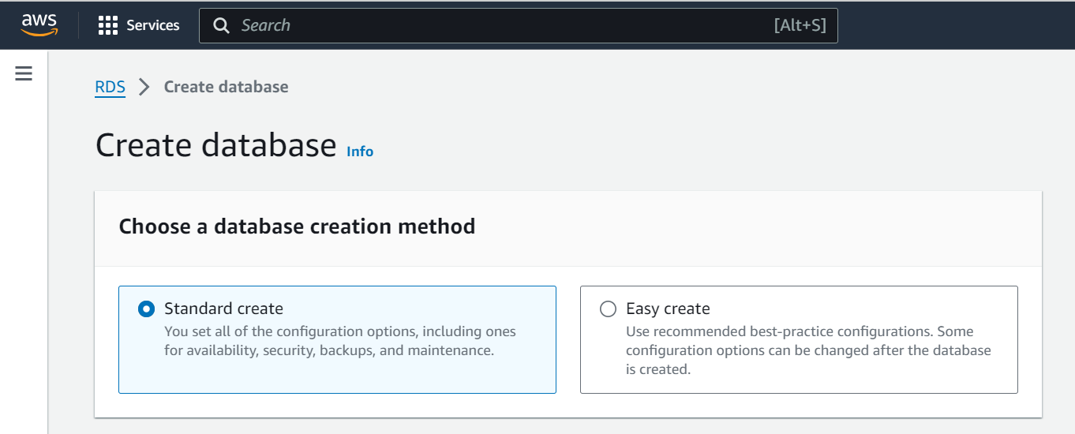

* Select Standard create
* Choose MySQL

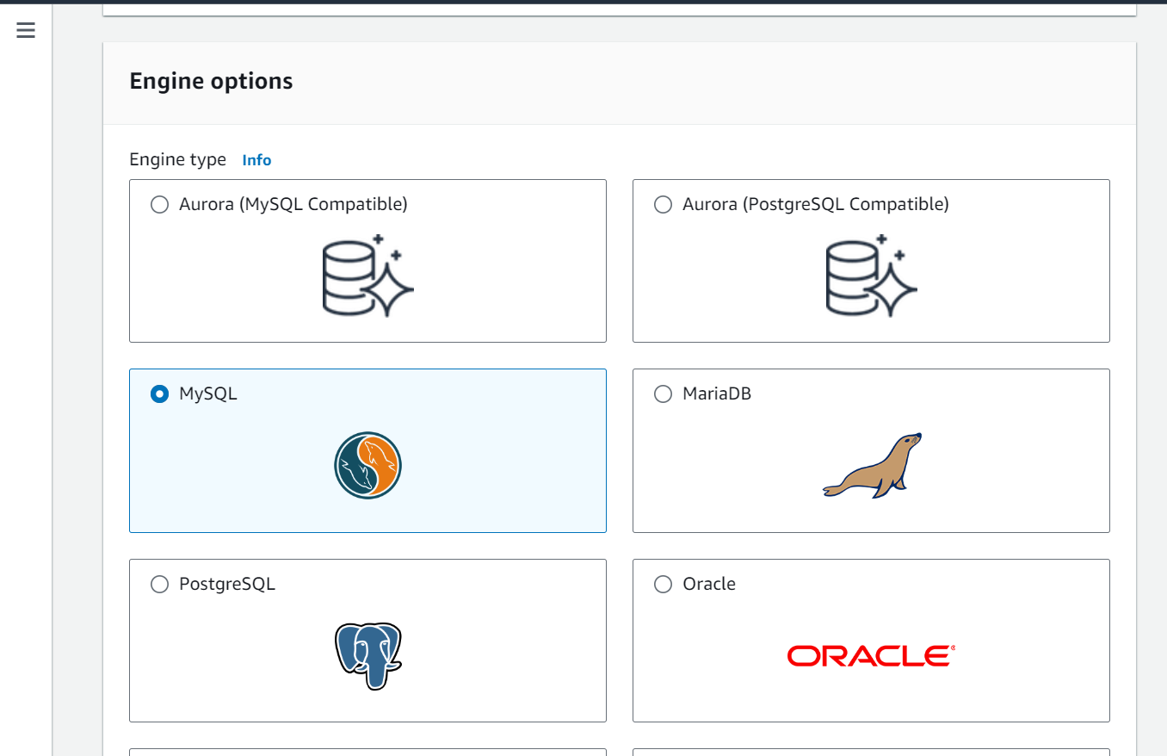

* Choose the version of MySQL

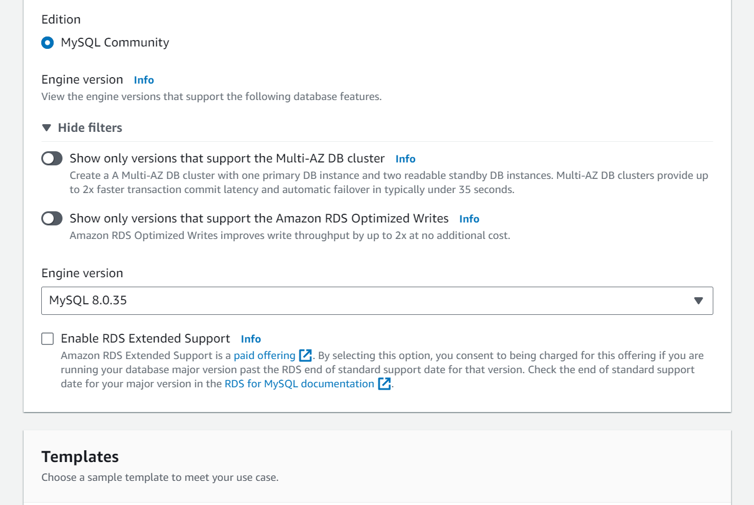

* Choose free tier

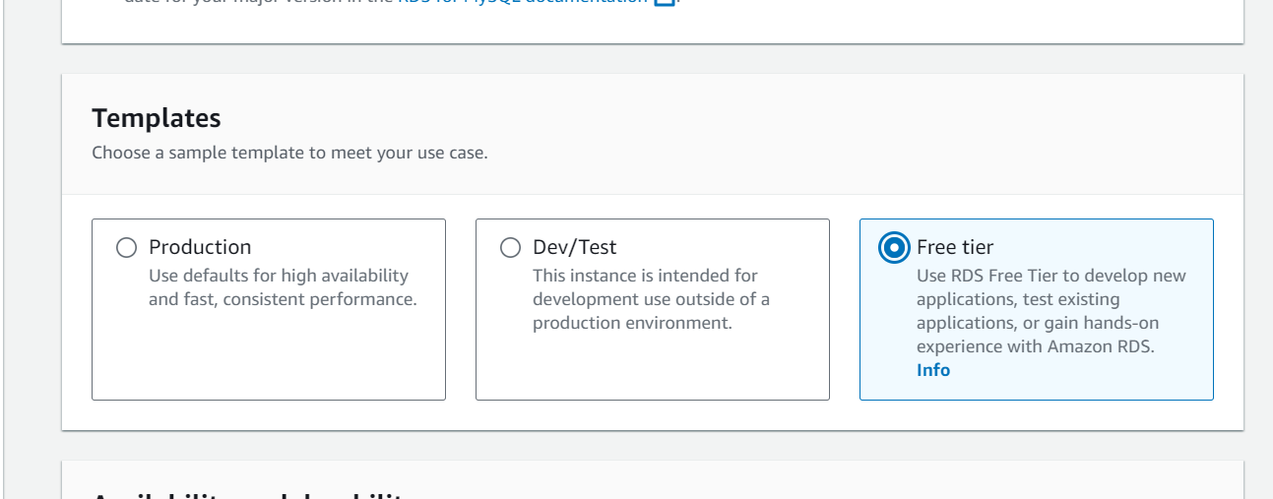

* Choose self managed

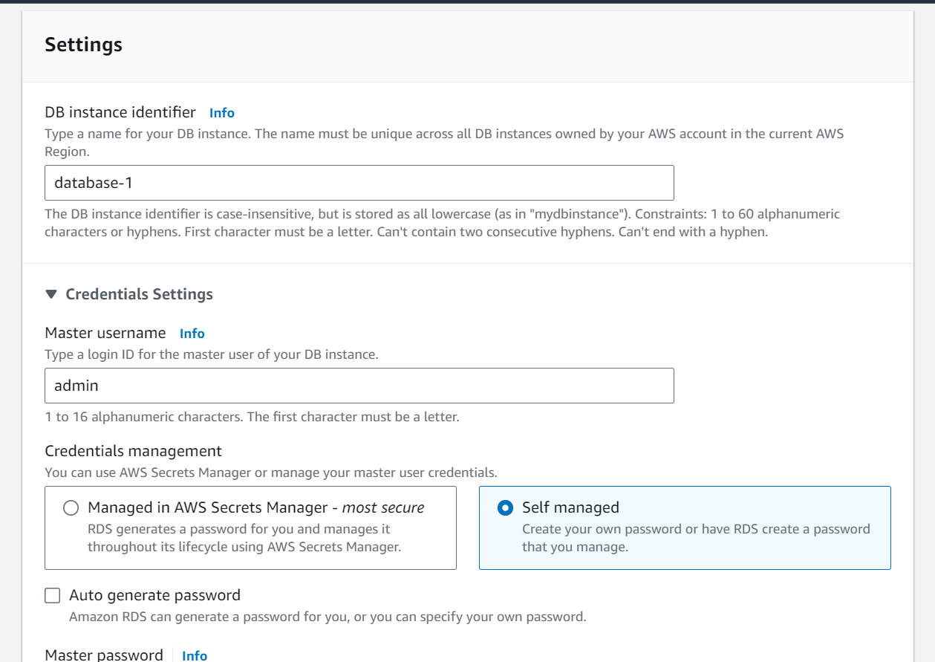

* Create a strong password for your RDS

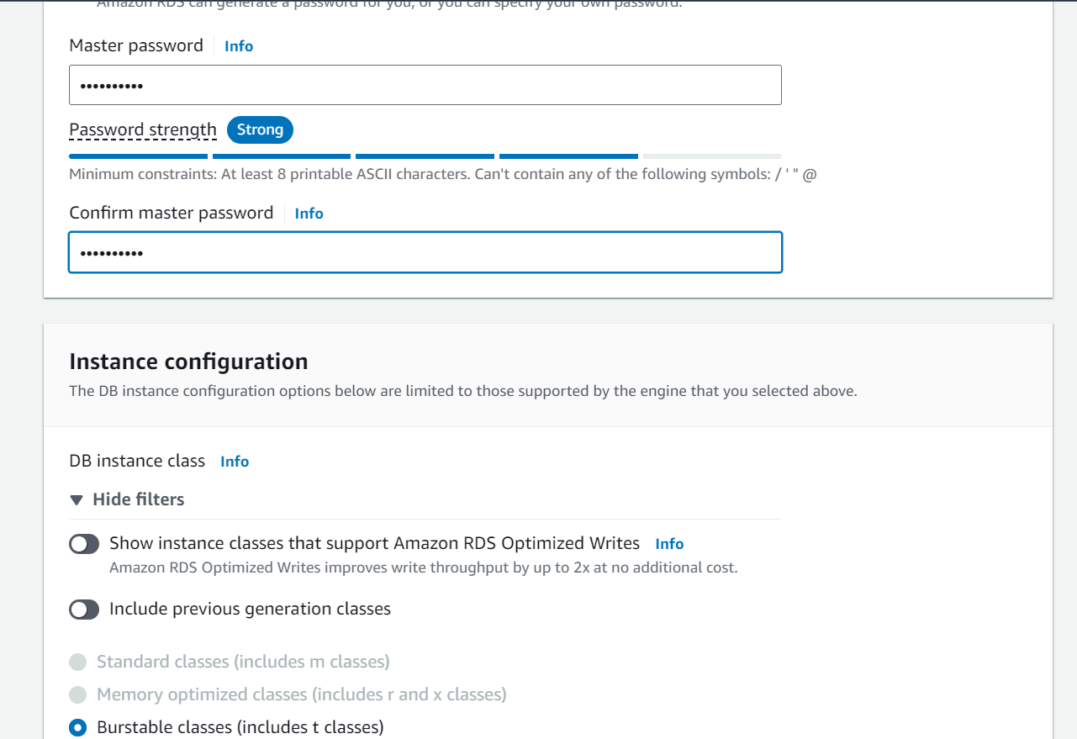

* Choose db.t4g.micro

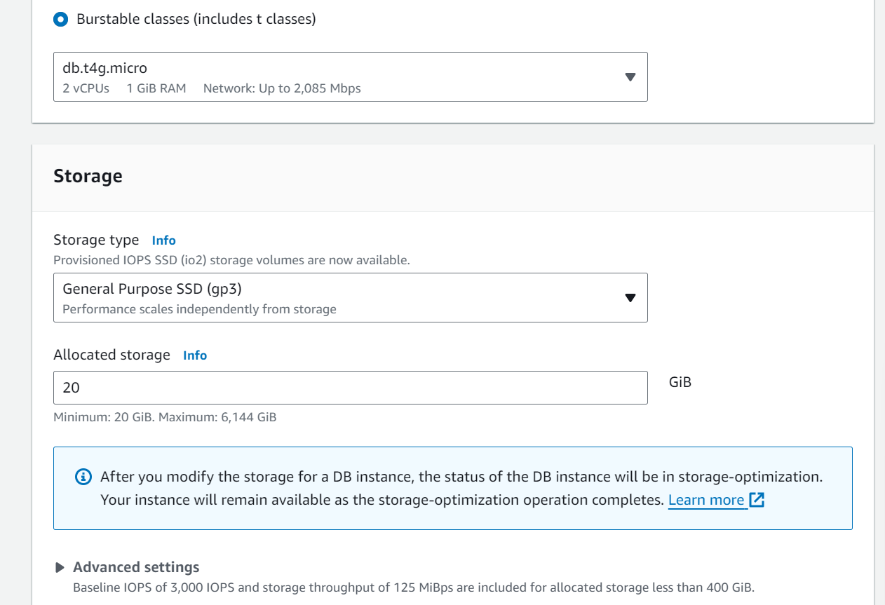

* Choose don’t connect to an EC2 computer resource

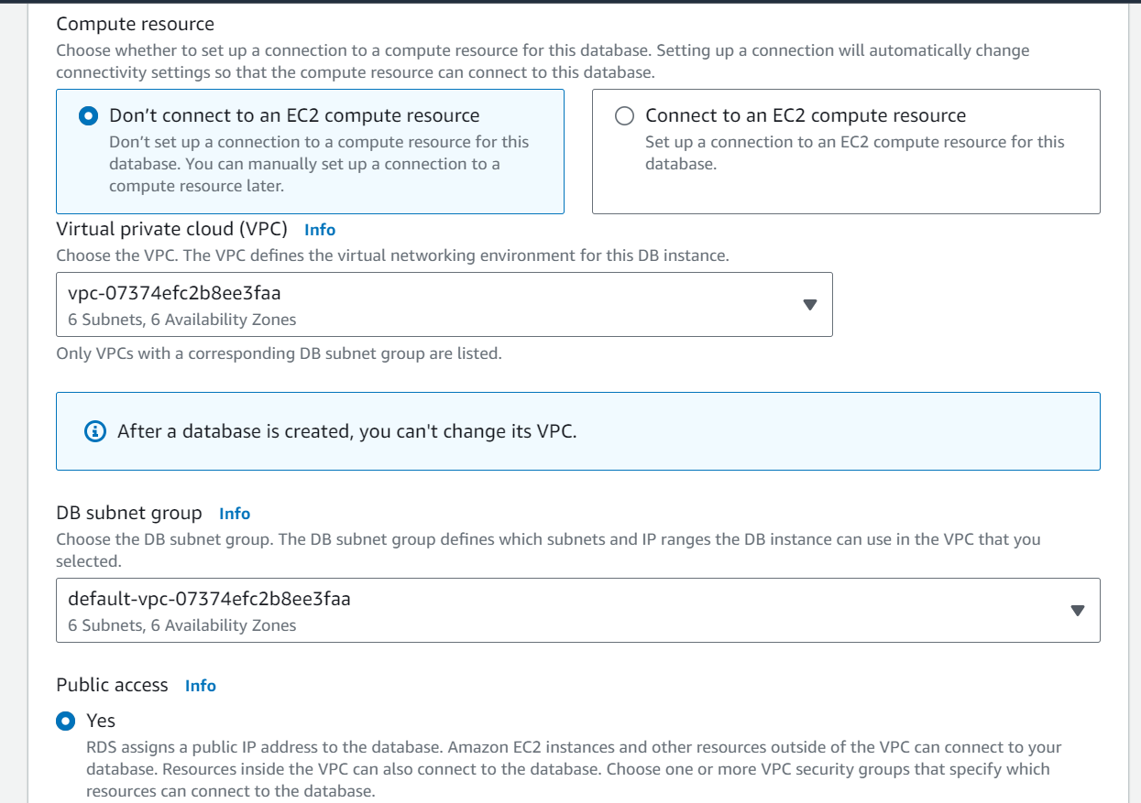

* Create a new VPC and name it.

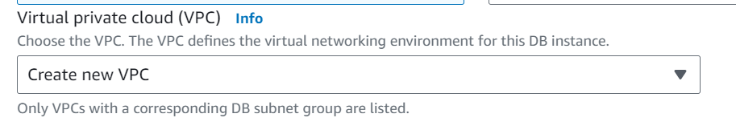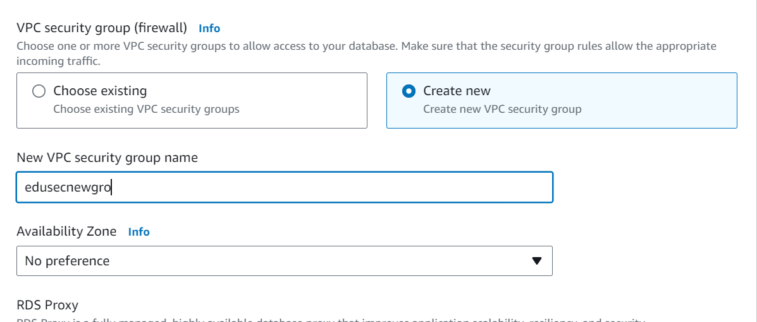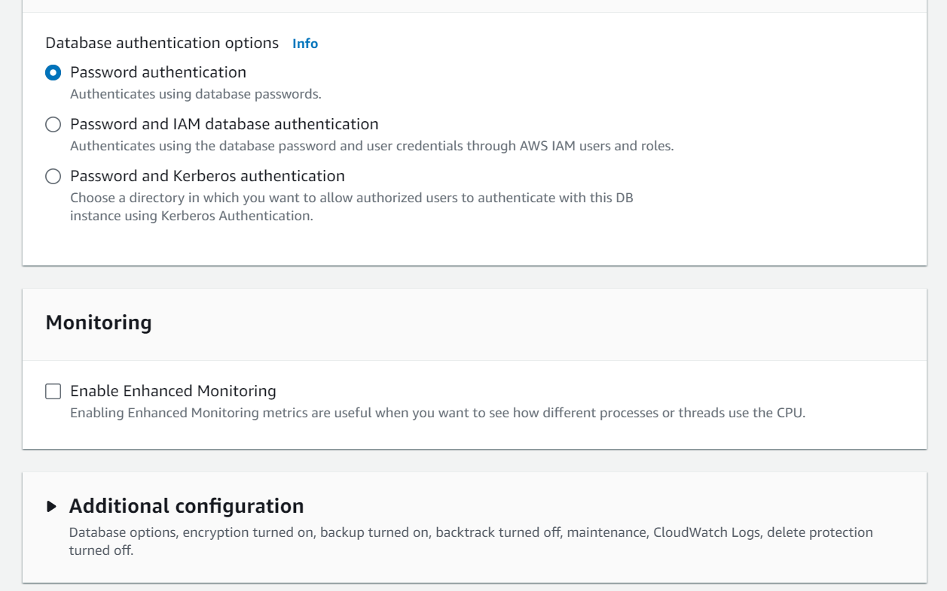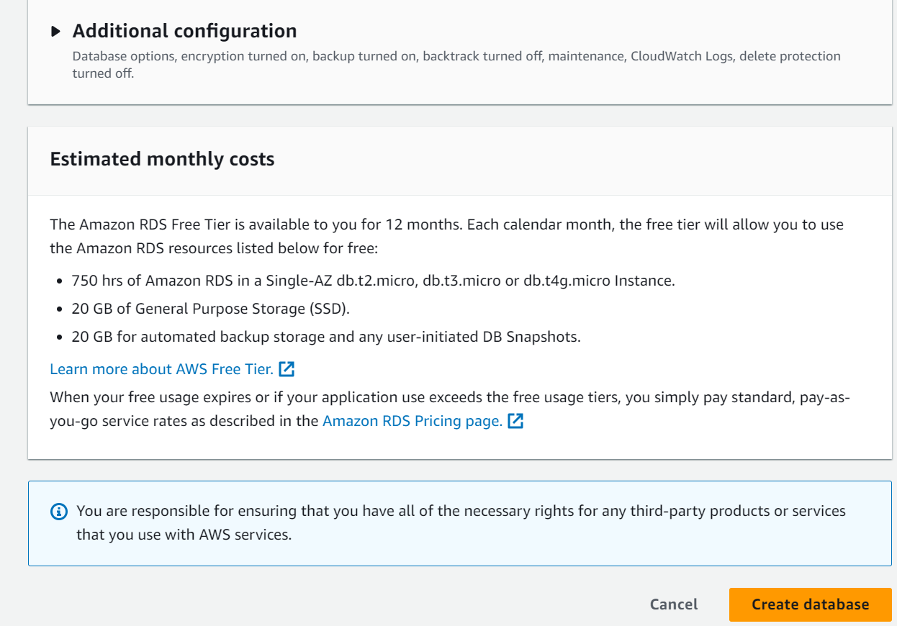Finally, click on Create Database

* **Activity 2.2: Configure Database Access**
  + Set up security groups, create database credentials, and configure access policies to ensure secure connectivity to the database.
* **Activity 2.3: Install MySQL Workbench**

Download and install MySQL Workbench on your local machine for database management.

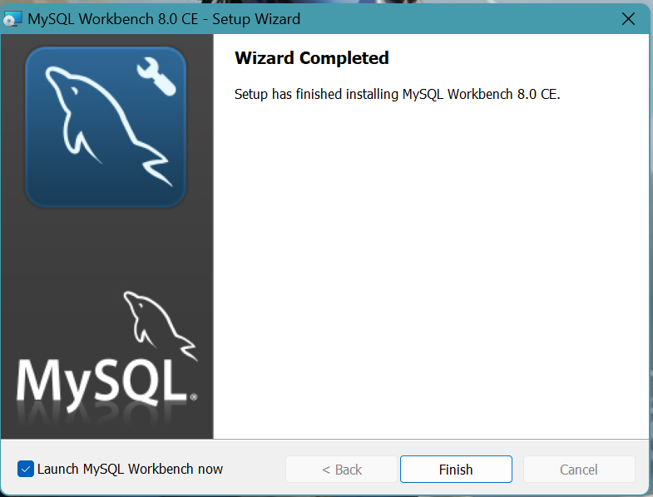

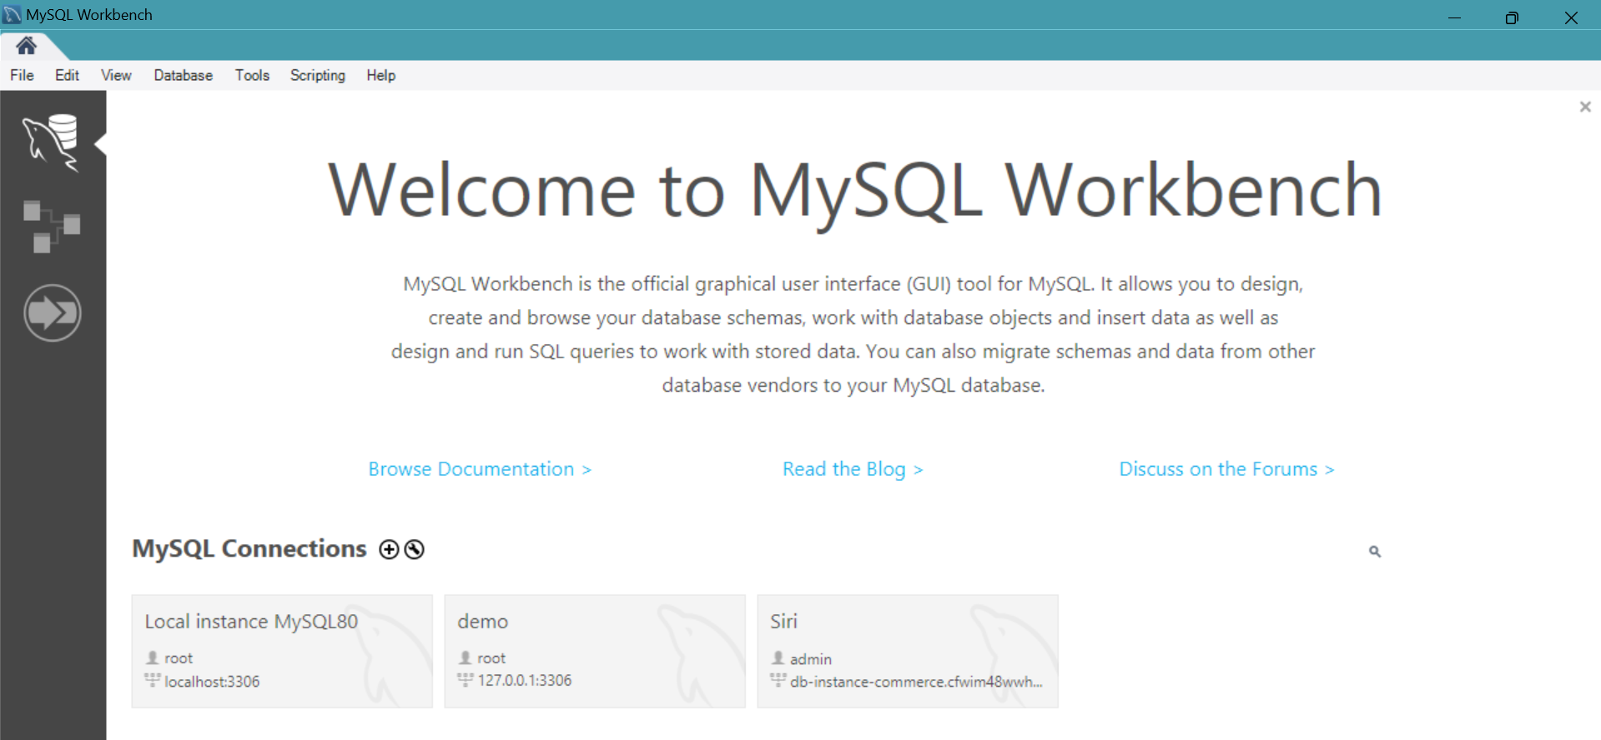

* Connect to the RDS instance via MySQL Workbench using the endpoint and credentials from AWS

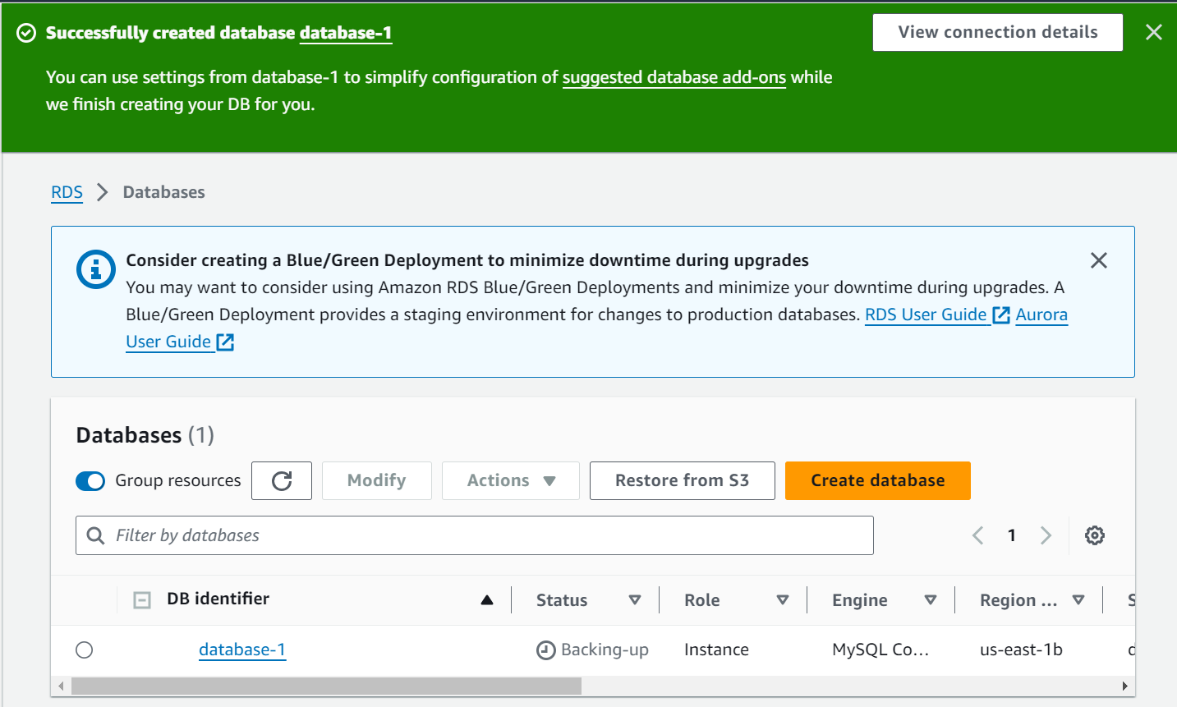

* Once the database is created, click on it.

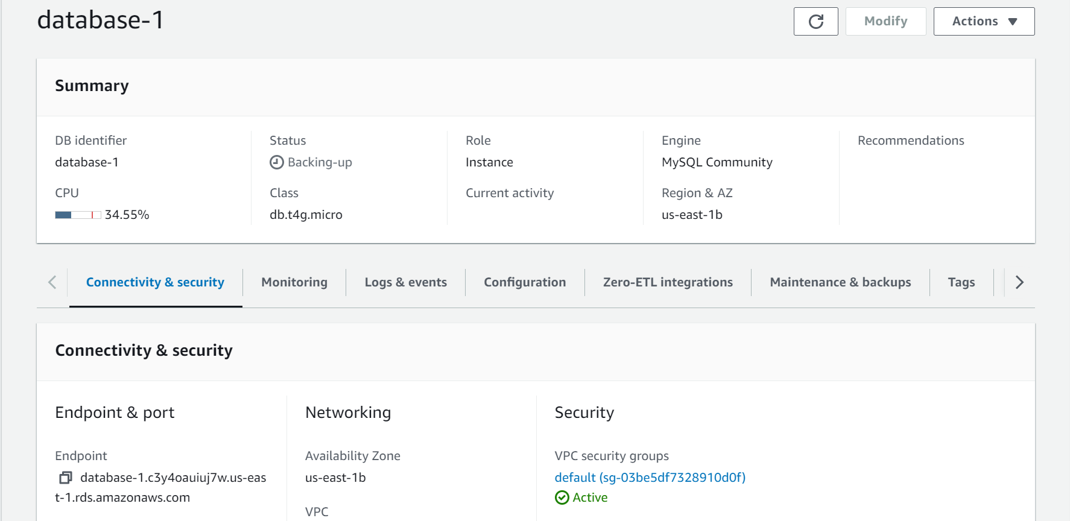

* Copy the Endpoint

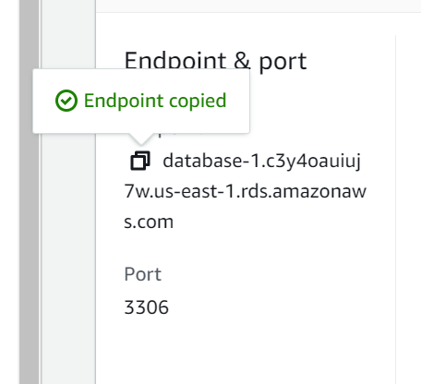

* Paste the endpoint in the Hostname
* Click on Store in Vault beside password

### **Activity 2.4: Connect to RDS using MySQL Client**

1. Install MySQL client on your local machine if not already done.
2. Use the following command to connect to your RDS instance:  
    Copy  
   mysql -h <your-rds-endpoint> -P 3306 -u <your-username> -p
3. Enter your RDS master password when prompted.

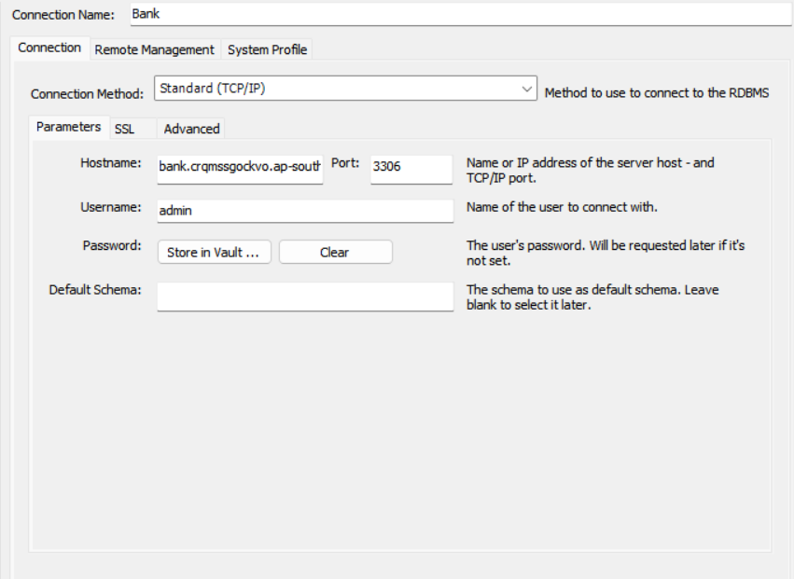

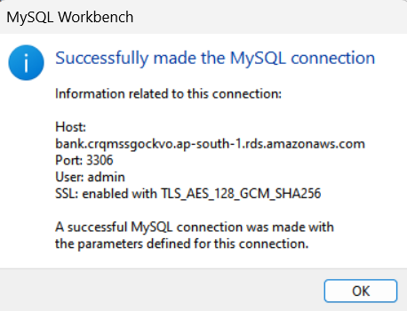

**Queries to create tables in MySQL workbench or MySQL Command Line:**

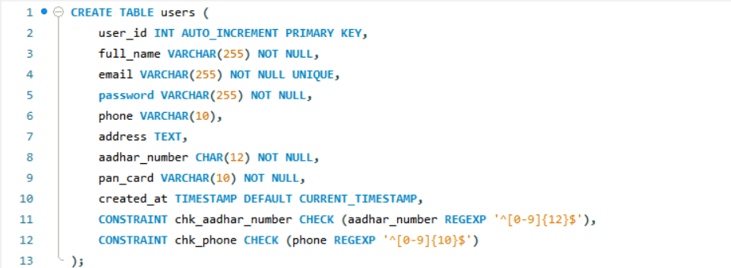

Columns:

* user_id: An auto-incrementing integer primary key that uniquely identifies each user.
* full_name: A variable-length string (up to 255 characters) that stores the user's full name.
* email: A variable-length string (up to 255 characters) that stores the user's email address. The UNIQUE constraint ensures that each email address is unique across all users.
* password: A variable-length string (up to 255 characters) that stores the user's password.
* phone: A variable-length string (up to 10 characters) that stores the user's phone number.
* address: A text column that stores the user's address.
* aadhar_number: A 12-character string that stores the user's Aadhaar number (a unique identification number issued by the Indian government).
* pan_card: A 10-character string that stores the user's PAN card number (a unique identification number issued by the Indian government).
* created_at: A timestamp column that stores the date and time when the user account was created. The DEFAULT CURRENT_TIMESTAMP clause sets the default value to the current timestamp when a new row is inserted.

Constraints:

* chk_aadhar_number: A check constraint that ensures the aadhar_number column only contains 12 digits (using a regular expression to match exactly 12 digits).
* chk_phone: A check constraint that ensures the phone column only contains 10 digits (using a regular expression to match exactly 10 digits).

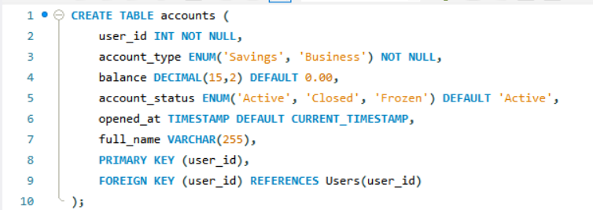

Columns:

* user_id: An integer column that stores the ID of the user who owns the account. This column is not nullable, meaning it must always contain a value.
* account_type: An enumeration column that stores the type of account, which can be either 'Savings' or 'Business'. This column is not nullable.
* balance: A decimal column that stores the current balance of the account, with a maximum of 15 digits and 2 decimal places. The default value is 0.00.
* account_status: An enumeration column that stores the status of the account, which can be 'Active', 'Closed', or 'Frozen'. The default value is 'Active'.
* opened_at: A timestamp column that stores the date and time when the account was opened. The default value is the current timestamp.
* full_name: A variable-length string (up to 255 characters) that stores the full name of the account holder.

Constraints:

* PRIMARY KEY (user_id): This constraint defines the user_id column as the primary key of the table, meaning it uniquely identifies each row in the table.
* FOREIGN KEY (user_id) REFERENCES Users(user_id): This constraint establishes a relationship between the accounts table and the users table. It ensures that the user_id column in the accounts table only contains values that exist in the user_id column of the users table. This is known as a foreign key constraint.

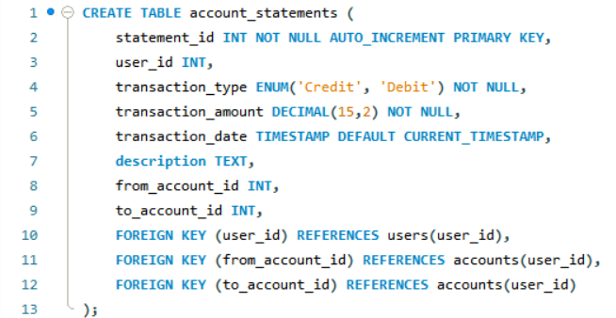

Columns:

* statement_id: An auto-incrementing integer primary key that uniquely identifies each statement.
* user_id: An integer column that stores the ID of the user who owns the account related to the statement.
* transaction_type: An enumeration column that stores the type of transaction, which can be either 'Credit' or 'Debit'. This column is not nullable.
* transaction_amount: A decimal column that stores the amount of the transaction, with a maximum of 15 digits and 2 decimal places. This column is not nullable.
* transaction_date: A timestamp column that stores the date and time when the transaction occurred. The default value is the current timestamp.
* description: A text column that stores a description of the transaction.
* from_account_id: An integer column that stores the ID of the account from which the transaction originated.
* to_account_id: An integer column that stores the ID of the account to which the transaction was sent.

Constraints:

* FOREIGN KEY (user_id) REFERENCES users(user_id): This constraint establishes a relationship between the account_statements table and the users table. It ensures that the user_id column in the account_statements table only contains values that exist in the user_id column of the users table.
* FOREIGN KEY (from_account_id) REFERENCES accounts(account_id): This constraint establishes a relationship between the account_statements table and the accounts table. It ensures that the from_account_id column in the account_statements table only contains values that exist in the account_id column of the accounts table.
* FOREIGN KEY (to_account_id) REFERENCES accounts(account_id): This constraint establishes a relationship between the account_statements table and the accounts table. It ensures that the to_account_id column in the account_statements table only contains values that exist in the account_id column of the accounts table.

**Milestone 3: EC2 Deployment**

**Activity 1: Launch EC2 Instance**

1. Access EC2 Console from the AWS Management Console.

2. Launch a new EC2 instance:

- Choose an Amazon Linux 2 AMI.

- Select an appropriate instance type (e.g., t2.micro for testing).

- Configure instance details, including VPC and subnet.

- Add storage as needed.

Configure security group to allow SSH (port 22) and HTTP/HTTPS (ports 80/443).

3. Create or select an existing key pair for SSH access.

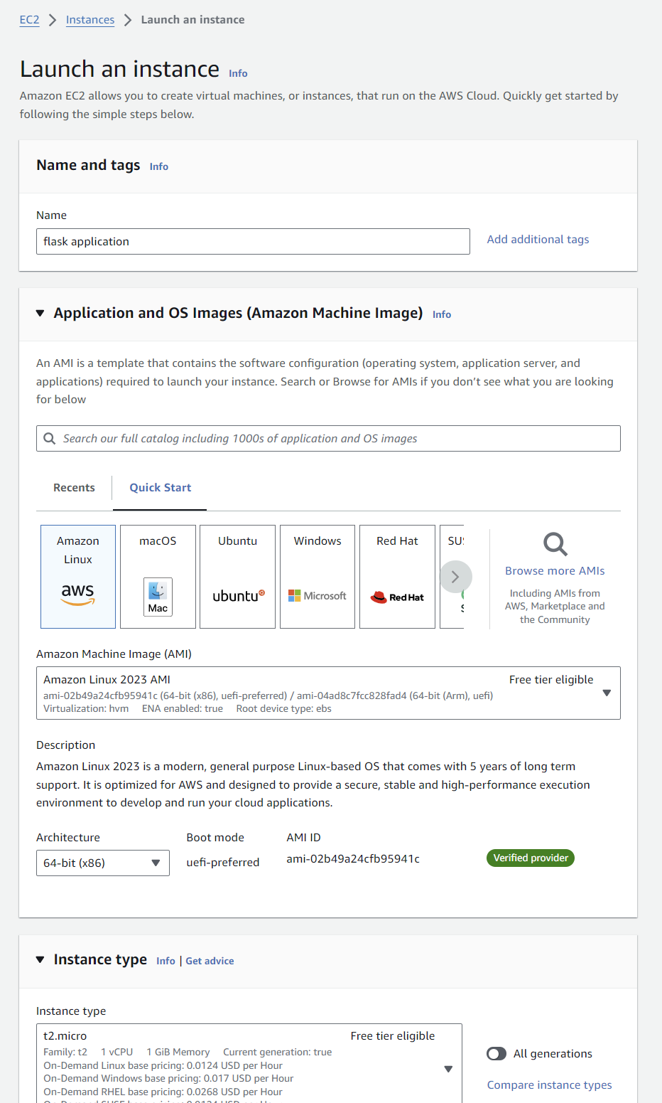

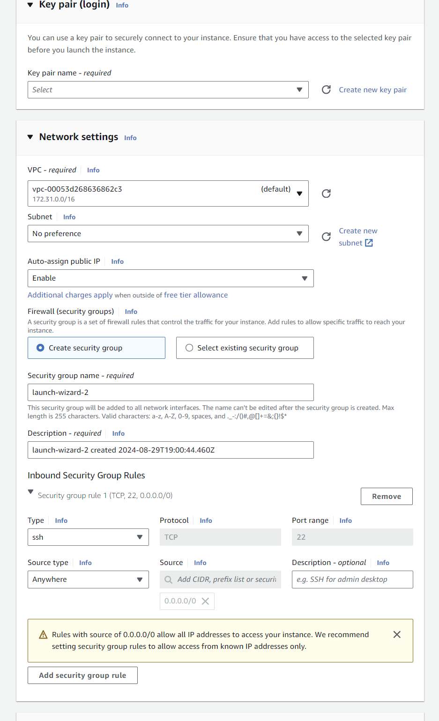

#### **Milestone 4: Develop Easybank Web Application**

**Activity 1: Set Up Local Development Environment**

1. Install Python and pip on your local machine.

2. Install Flask and other necessary Python packages (e.g., `flask-sqlalchemy`, `mysql-connector-python`).

3. Set up a virtual environment for your project.

**Activity 2: Create Flask Application Structure**

1. Create a new directory for your Easybank project.

2. Set up a basic Flask application structure:

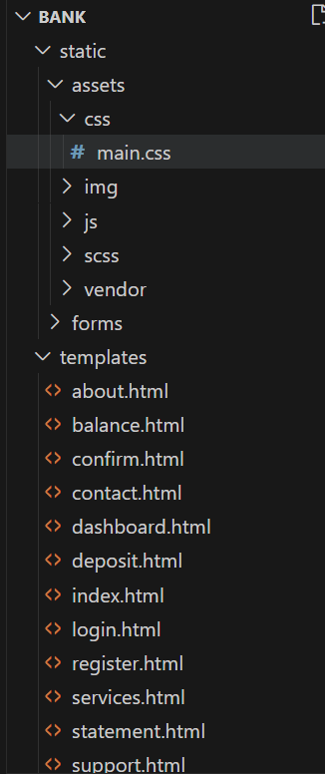

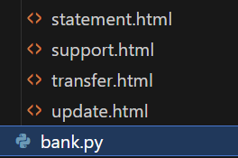

**Activity 2: Create Web Pages**

1. Design and create HTML templates for your banking application, including:

- Home page

- User registration page

- Login page

- Account dashboard

- Transaction page

- Account creation page

- Check Balance page

- Deposit page

- Services page

- Contact Page

- confirm page

-Account Login page

- Statement page

2. Place these templates in the `templates/` directory.

3. Create CSS files in the `static/css/` directory for styling.

4. Add any necessary JavaScript files in the `static/js/` directory.

**Activity 3: Implement Flask Routes and Views**

1. In `app.py`, create Flask routes for each of your web pages.

2. Implement view functions to render the appropriate templates.

3. Add form handling for user input (registration, login, transactions, etc.).

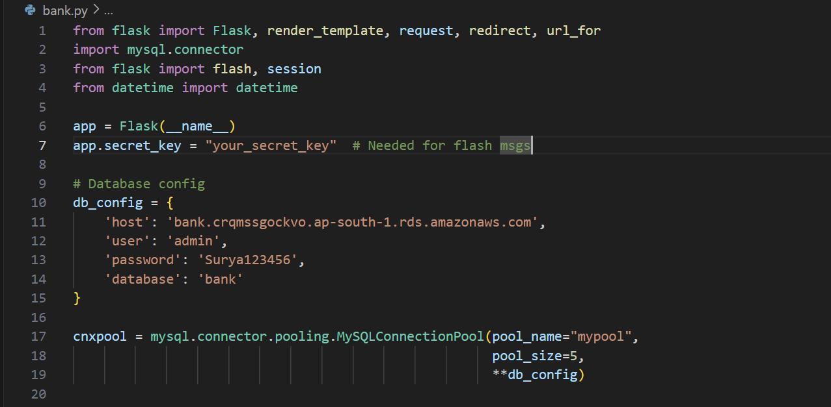

1. from flask import Flask, render_template, request, redirect, url_for:
   * Imports the necessary modules from the Flask web framework.
   * Flask is the main application class.
   * render_template is used to render HTML templates.
   * request is used to access the current request object.
   * redirect is used to redirect the user to a different URL.
   * url_for is used to generate URLs for routes.
2. import mysql.connector:
   * Imports the MySQL Connector/Python module, which is used to connect to a MySQL database.
3. from flask import flash, session:
   * Imports the flash and session modules from Flask.
   * flash is used to display flash messages to the user.
   * session is used to store and retrieve data in the user's session.
4. from datetime import datetime:
   * Imports the datetime module, which is used to work with dates and times.
5. app = Flask(__name__):
   * Creates a new Flask application instance, passing the current module name as the argument.
6. app.secret_key = "your_secret_key":
   * Sets the secret key for the application, which is used to securely store and retrieve data in the session.
7. db_config = {...}:
   * Defines a dictionary db_config that contains the database configuration settings.
   * The settings include the host, user, password, and database name.
8. cnxpool = mysql.connector.pooling.MySQLConnectionPool(...):
   * Creates a MySQL connection pool using the mysql.connector.pooling module.
   * The connection pool is configured with the pool_name, pool_size, and db_config settings.
   * The **db_config syntax is used to unpack the db_config dictionary and pass its key-value pairs as arguments to the MySQLConnectionPool constructor.

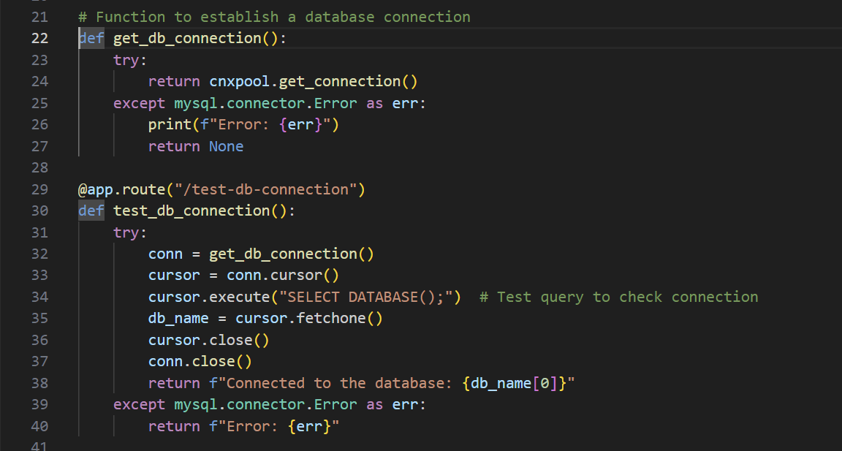

The provided code is used to:

1. Establish a connection to a MySQL database using a connection pool.
2. Test the connection by executing a query.
3. Handle any errors that occur during the connection process.

The code consists of two functions:

1. get_db_connection(): Establishes a connection to the database and returns it, or None if an error occurs.
2. test_db_connection(): Tests the connection, executes a query, and returns a success or error message.

# Define your routes here

@app.route("/")

def index():

try:

conn = get_db_connection()

cursor = conn.cursor()

except mysql.connector.Error as err:

print(f"Error: {err}")

finally:

if conn:

cursor.close()

conn.close()

return render_template("index.html")

This code defines a Flask route for the root URL ("/") that:

1. Tries to establish a database connection and create a cursor.
2. Catches and prints any database connection errors.
3. Closes the cursor and connection in a finally block to release resources.
4. Returns the rendered "index.html" template.

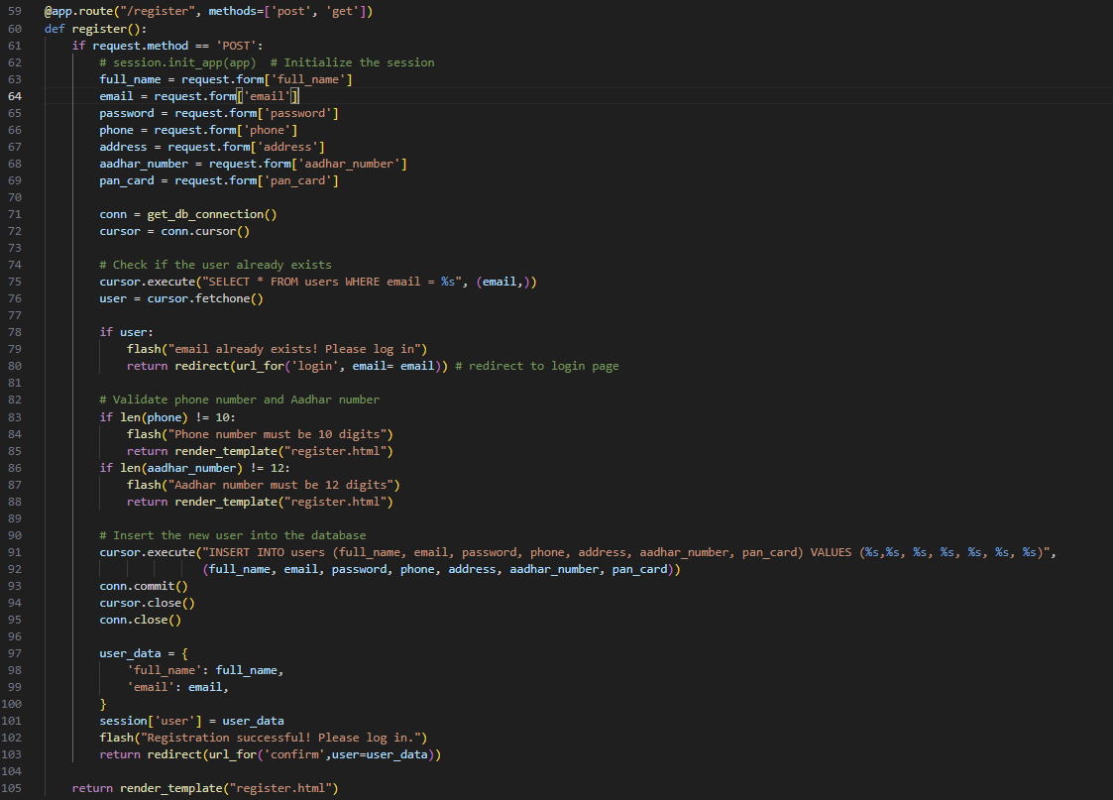

/register Route

The /register route handles both GET and POST requests. When a POST request is made, it:

1. Retrieves user input from the form data.
2. Establishes a connection to the MySQL database.
3. Checks if a user with the provided email already exists in the database. If they do, it flashes an error message and redirects to the login page.
4. Validates the phone number and Aadhar number to ensure they meet the required length.
5. Inserts the new user into the database.
6. Commits the changes and closes the cursor and connection.
7. Creates a session for the new user and flashes a success message.
8. Redirects to the confirm page with the user data.

If the request is a GET request, it simply renders the register.html template.

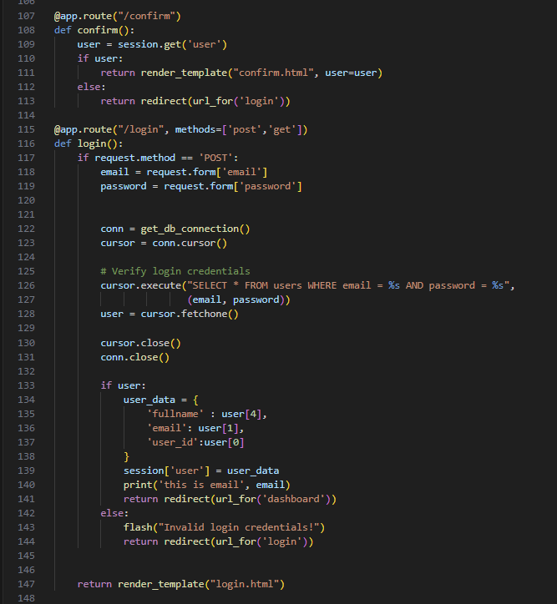

/confirm Route

The /confirm route is used to render the confirmation page for a logged-in user. Here's what it does:

1. It checks if a user is logged in by retrieving the user data from the session.
2. If a user is logged in, it renders the confirm.html template and passes the user data to it.
3. If no user is logged in, it redirects to the login page.

/login Route

The /login route handles both GET and POST requests for user login. Here's what it does:

GET Request

1. It renders the login.html template, which is the login form.

POST Request

1. It retrieves the email and password from the form data.
2. It establishes a connection to the MySQL database using the get_db_connection() function.
3. It creates a cursor object to execute SQL queries.
4. It executes a SQL query to verify the login credentials by selecting all columns (*) from the users table where the email and password match the provided values.
5. It fetches the result of the query using the fetchone() method.
6. It closes the cursor and connection to the database.
7. If a user is found (i.e., the query returns a result), it:
   * Creates a user_data dictionary with the user's full name, email, and user ID.
   * Stores the user_data in the session.
   * Redirects to the dashboard page.
8. If no user is found (i.e., the query returns None), it:
   * Flashes an error message indicating invalid login credentials.
   * Redirects to the login page.

@app.route("/dashboard")

def dashboard():

user_data = session.get('user')

if user_data:

email = user_data['email']

conn = get_db_connection()

cursor = conn.cursor()

cursor.execute("SELECT * FROM users WHERE email = %s", (email,))

user = cursor.fetchone()

cursor.close()

conn.close()

return render_template("dashboard.html", user=user)

else:

return redirect(url_for('login'))

@app.route("/deposit", methods=['post', 'get'])

def deposit():

user_data = session.get('user')

if user_data:

if request.method == 'POST':

amount = float(request.form['deposit_amount'])

account_type = request.form['account_type']

conn = get_db_connection()

cursor = conn.cursor()

cursor.execute("SELECT 1 FROM accounts WHERE user_id = %s", (user_data['user_id'],))

if not cursor.fetchone():

# Insert a new row

cursor.execute("INSERT INTO accounts (user_id, balance, account_type) VALUES (%s, %s, %s)", (user_data['user_id'], amount, account_type))

cursor.execute("INSERT INTO account_statements (user_id, transaction_type,transaction_amount, transaction_date) VALUES (%s, 'Credit', %s, %s)", (user_data['user_id'], amount, datetime.now()))

else:

# Update the existing row

cursor.execute("UPDATE accounts SET balance = balance + %s WHERE user_id = %s", (amount, user_data['user_id']))

cursor.execute("INSERT INTO account_statements (user_id, transaction_type,transaction_amount, transaction_date) VALUES (%s, 'Credit', %s, %s)", (user_data['user_id'], amount, datetime.now()))

conn.commit()

cursor.close()

conn.close()

flash("Funds deposited successfully!")

return redirect(url_for('dashboard'))

return render_template("deposit.html")

else:

return redirect(url_for('login'))

/dashboard Route

The /dashboard route is used to render the dashboard page for a logged-in user. Here's what it does:

1. It checks if a user is logged in by retrieving the user_data from the session.
2. If a user is logged in, it:
   * Retrieves the user's email from the user_data.
   * Establishes a connection to the MySQL database using the get_db_connection() function.
   * Creates a cursor object to execute SQL queries.
   * Executes a SQL query to select all columns (*) from the users table where the email matches the user's email.
   * Fetches the result of the query using the fetchone() method.
   * Closes the cursor and connection to the database.
   * Renders the dashboard.html template and passes the user data to it.
3. If no user is logged in, it redirects to the login page.

/deposit Route

The /deposit route handles both GET and POST requests for depositing funds into a user's account. Here's what it does:

GET Request

1. It checks if a user is logged in by retrieving the user_data from the session.
2. If a user is logged in, it renders the deposit.html template.
3. If no user is logged in, it redirects to the login page.

POST Request

1. It retrieves the deposit amount and account type from the form data.
2. It establishes a connection to the MySQL database using the get_db_connection() function.
3. It creates a cursor object to execute SQL queries.
4. It checks if the user has an existing account by executing a SQL query to select 1 from the accounts table where the user_id matches the user's ID.
5. If no account exists, it:
   * Inserts a new row into the accounts table with the user's ID, deposit amount, and account type.
   * Inserts a new row into the account_statements table with the user's ID, transaction type (Credit), deposit amount, and current date and time.
6. If an account exists, it:
   * Updates the existing row in the accounts table by adding the deposit amount to the balance.
   * Inserts a new row into the account_statements table with the user's ID, transaction type (Credit), deposit amount, and current date and time.
7. It commits the changes to the database.
8. It closes the cursor and connection to the database.
9. It flashes a success message indicating that the funds have been deposited successfully.
10. It redirects to the dashboard page.

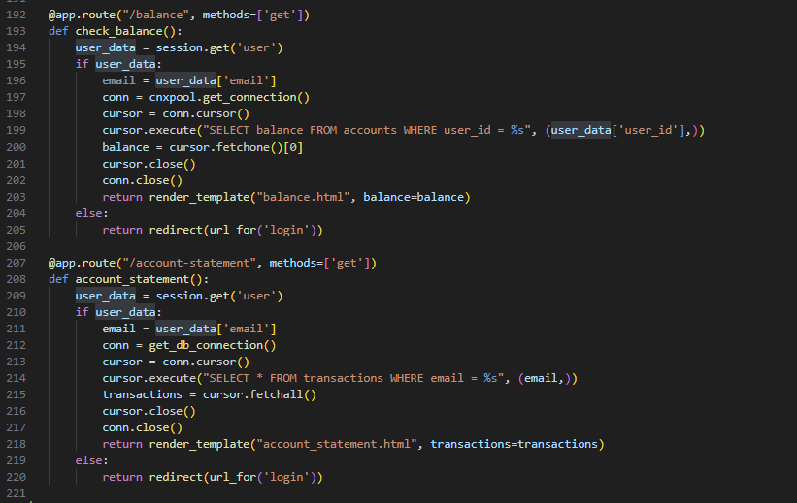

/balance Route

The /balance route is used to display a user's current account balance. Here's what it does:

1. It checks if a user is logged in by retrieving the user_data from the session.
2. If a user is logged in, it:
   * Retrieves the user's email from the user_data.
   * Establishes a connection to the MySQL database using the cnxpool.get_connection() function.
   * Creates a cursor object to execute SQL queries.
   * Executes a SQL query to select the balance column from the accounts table where the user_id matches the user's ID.
   * Fetches the result of the query using the fetchone() method and extracts the balance value from the result.
   * Closes the cursor and connection to the database.
   * Renders the balance.html template and passes the balance value to it.
3. If no user is logged in, it redirects to the login page.

/account-statement Route

The /account-statement route is used to display a user's account statement, which includes a list of transactions. Here's what it does:

1. It checks if a user is logged in by retrieving the user_data from the session.
2. If a user is logged in, it:
   * Retrieves the user's email from the user_data.
   * Establishes a connection to the MySQL database using the get_db_connection() function.
   * Creates a cursor object to execute SQL queries.
   * Executes a SQL query to select all columns (*) from the transactions table where the email matches the user's email.
   * Fetches all the results of the query using the fetchall() method and stores them in the transactions variable.
   * Closes the cursor and connection to the database.
   * Renders the account_statement.html template and passes the transactions list to it.
3. If no user is logged in, it redirects to the login page.

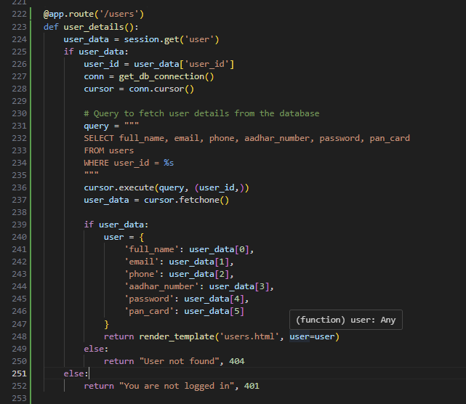

This code defines a Flask route /users that:

1. Checks if a user is logged in by retrieving user_data from the session.
2. If logged in, connects to a database, executes a SQL query to fetch user details, and stores them in a dictionary.
3. Renders an HTML template (users.html) with the user's details.
4. If not logged in, returns a "You are not logged in" message with a 401 status code.
5. If the user is not found in the database, returns a "User not found" message with a 404 status code.

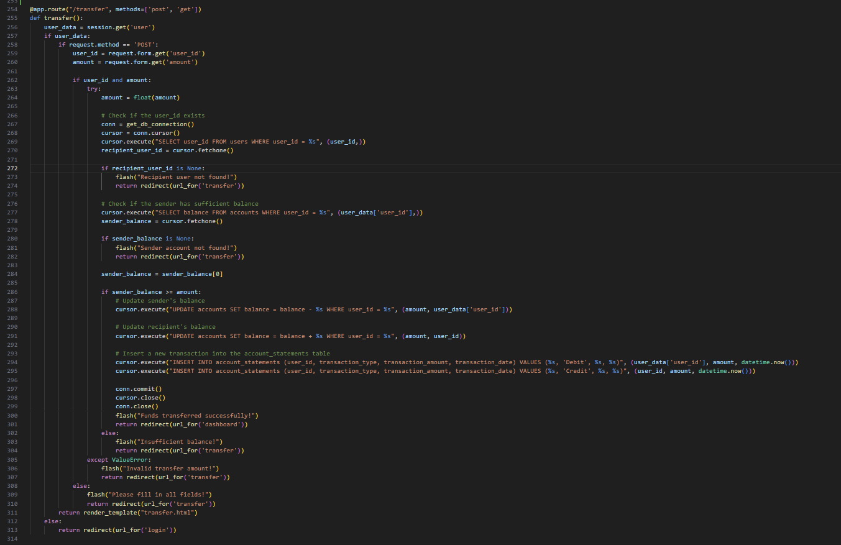

What the code does:

This code helps people send money to each other online. It's like a digital wallet that lets you transfer money to someone else's account.

How it works:

1. The code checks if you're logged in to your account. If not, it asks you to log in first.
2. When you try to send money, the code checks if you've filled in all the necessary information (like the person's ID and the amount you want to send).
3. It then checks if the person you're trying to send money to actually exists in the system.
4. Next, it checks if you have enough money in your account to make the transfer.
5. If everything is okay, it takes the money from your account and adds it to the other person's account.
6. It also keeps a record of the transaction, so you can see a history of all your transfers.
7. Finally, it tells you that the transfer was successful and takes you back to your account dashboard.

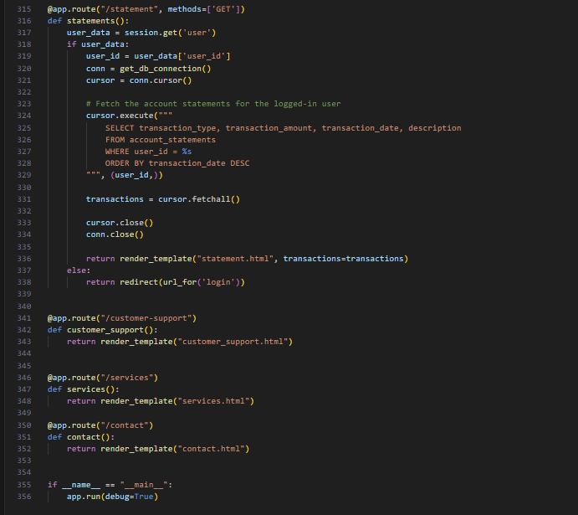

Route 1: /statement This route is defined to handle GET requests to the /statement endpoint. The statements() function is called when this route is accessed.

* It first checks if there is a user session variable set. If it is, it extracts the user_id from the session data.
* It then establishes a database connection using get_db_connection() and creates a cursor object.
* The cursor executes a SQL query to fetch the account statements for the logged-in user. The query selects four columns: transaction_type, transaction_amount, transaction_date, and description from the account_statements table. The WHERE clause filters the results to only include statements for the current user, and the ORDER BY clause sorts the results by transaction_date in descending order (newest transactions first).
* The fetchall() method retrieves all the rows from the query result, which are stored in the transactions variable.
* The cursor and connection are closed to free up resources.
* Finally, the render_template() function is called to render the statement.html template, passing the transactions variable as a parameter.

Route 2: /customer-support This route is defined to handle GET requests to the /customer-support endpoint. The customer_support() function is called when this route is accessed.

* It simply returns the rendered customer_support.html template.

Route 3: /services This route is defined to handle GET requests to the /services endpoint. The services() function is called when this route is accessed.

* It simply returns the rendered services.html template.

Route 4: /contact This route is defined to handle GET requests to the /contact endpoint. The contact() function is called when this route is accessed.

* It simply returns the rendered contact.html template.

Main Application The last line of the code checks if the script is being run directly (i.e., not being imported as a module). If so, it starts the Flask development server in debug mode using app.run(debug=True).

In summary, this code defines a Flask web application with four routes: /statement, /customer-support, /services, and /contact. The /statement route fetches account statements for the logged-in user and renders an HTML template, while the other routes simply render static HTML templates.

**Activity 2: Configure EC2 Instance**

1. Connect to your EC2 instance using SSH.

2. Update the system and install necessary software:

sudo yum update -y

sudo yum install python3 python3-pip mysql -y

3. Install required Python packages:`

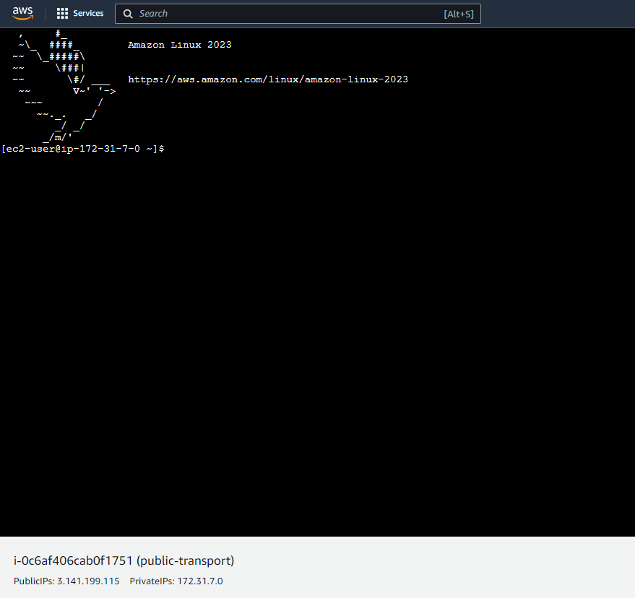

**Activity 3: Deploy Flask Application to EC2**

1. Transfer your application code to the EC2 instance.
2. Set up any necessary environment variables, including database connection strings.
3. Configure the web server to serve your application.
4. Start your application and ensure it's accessible via the EC2 instance's public IP or domain.
5. Run the below commands on ec2 terminal
6. sudo yum update -y
7. sudo yum install python3 -y
8. sudo pip3 install virtualenv
9. python3 -m venv venv
10. source venv/bin/activate
11. pip install flask
12. git clone [https://github.com/your-repo/your-flask-app](https://github.com/your-repo/your-flask-app.git)

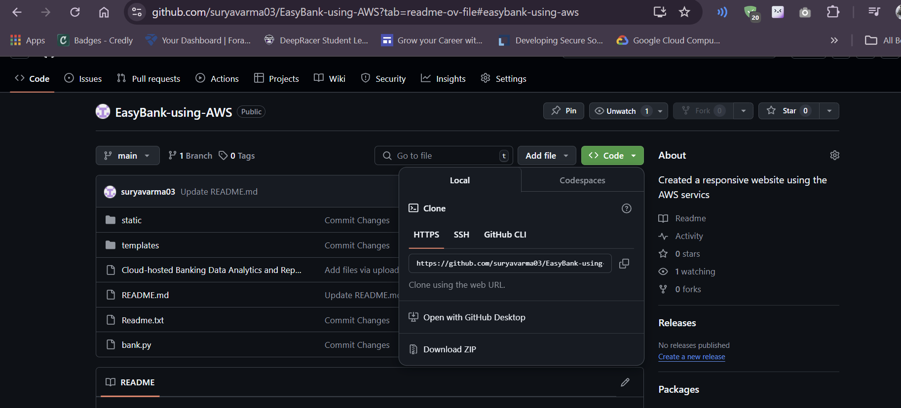

1. cd your-flask-app
2. python3 app.py



#### **Milestone 6: Monitoring and Management:**

**Activity 1: Set Up CloudWatch Monitoring**

1. Access the CloudWatch console from the AWS Management Console.

2. Create a new dashboard for your Easybank application.

3. Add widgets to monitor key metrics:

- EC2 instance CPU utilization, network traffic, and status checks

- RDS instance CPU utilization, free storage space, and database connections

- Application-specific metrics (e.g., number of transactions, active users)

4. Set up CloudWatch Alarms for critical thresholds (e.g., high CPU usage, low free storage).

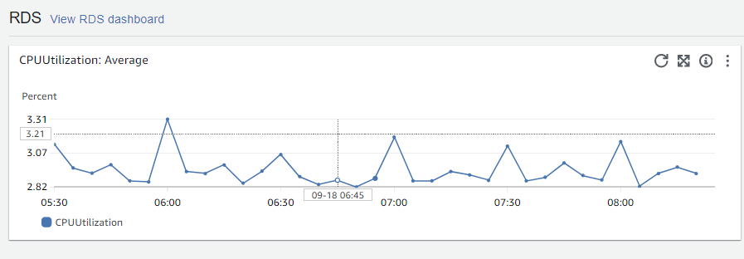

**Activity 2: Configure CloudWatch Logs**

1. Install and configure the CloudWatch Logs agent on your EC2 instance.

2. Set up log groups for your application logs, EC2 system logs, and Nginx logs (if applicable).

3. Create log filters to extract and analyze important log events.

**Milestone 7: Testing, Optimization, and Maintenance:**

**Activity 1: Conduct Thorough Testing**

1. Perform functionality testing of all banking features.

2. Conduct security testing, including penetration testing if possible.

3. Perform load testing to ensure the application can handle expected traffic.

**Activity 2: Optimize Performance**

1. Analyze and optimize database queries.

2. Implement caching mechanisms where appropriate (e.g., Flask-Caching).

3. Optimize front-end assets (minify CSS/JS, optimize images).

**Activity 3: Implement Backup and Disaster Recovery**

1. Configure automated RDS snapshots for database backups.

2. Set up a disaster recovery plan, including steps for failover to a different region if necessary.

**Activity 4: Continuous Improvement**

1. Regularly update EC2 instances and RDS with the latest security patches.

2. Monitor CloudWatch metrics and logs to identify areas for improvement.

3. Gather user feedback and iterate on the application features and user experience.

4. Continuously optimize AWS resource usage for cost-effectiveness.

**INDEX :**

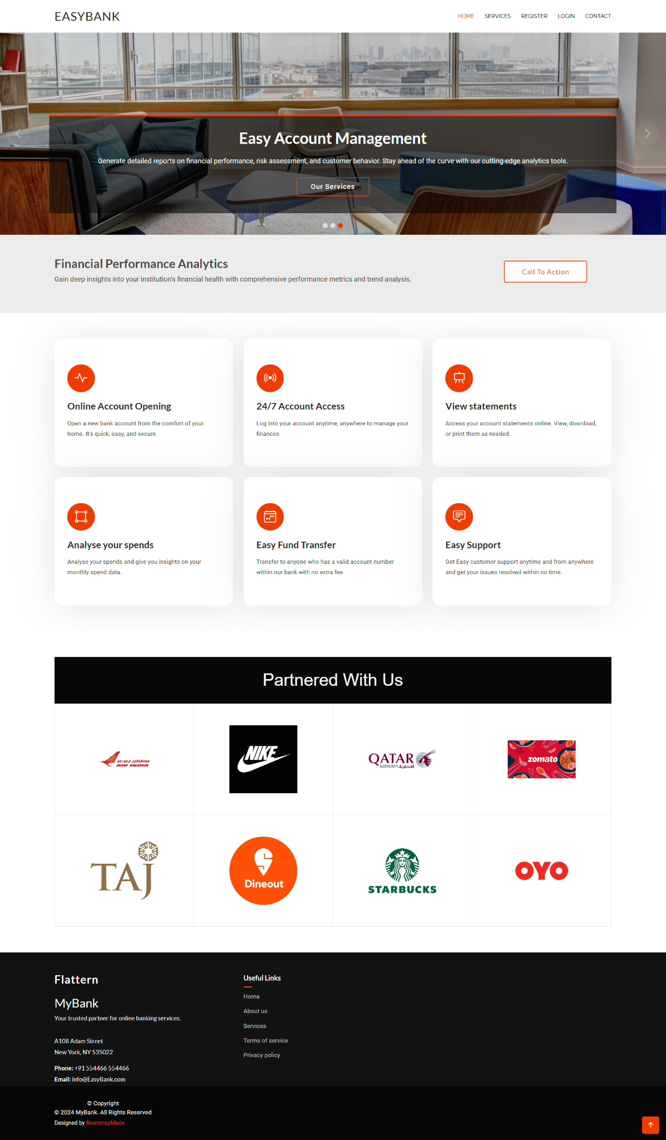

**SERVICE :**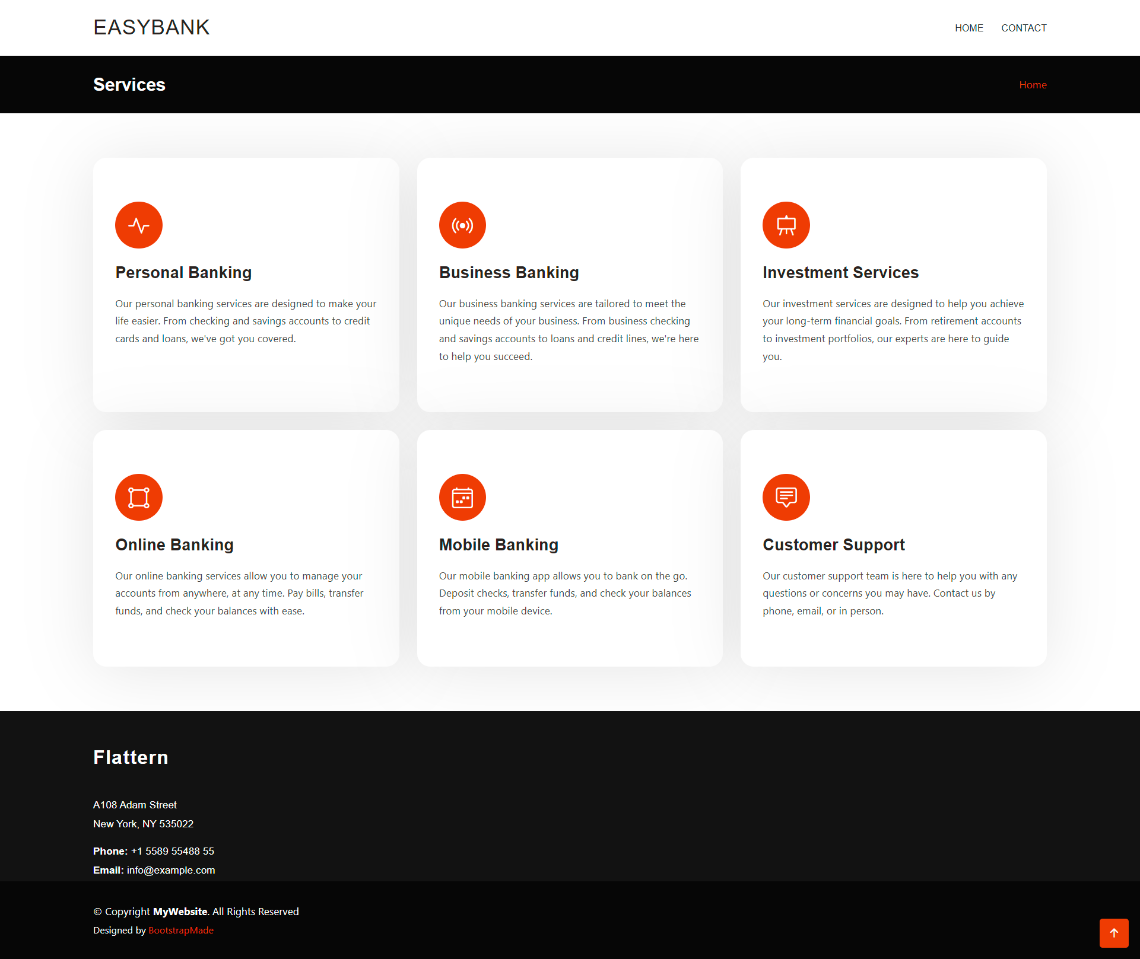

**LOGIN :**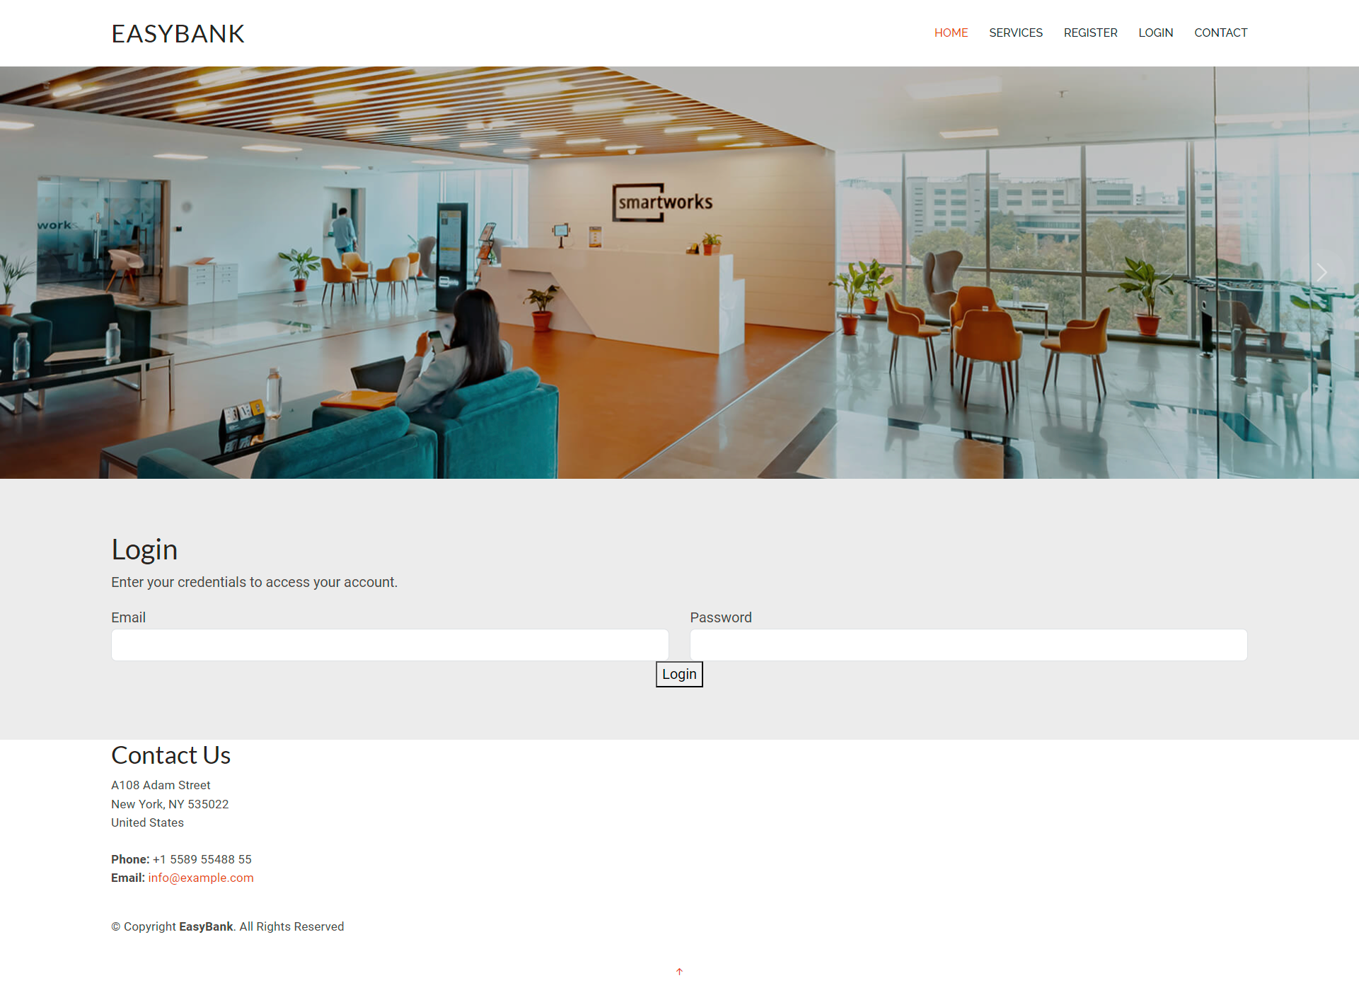

**REGISTER :**

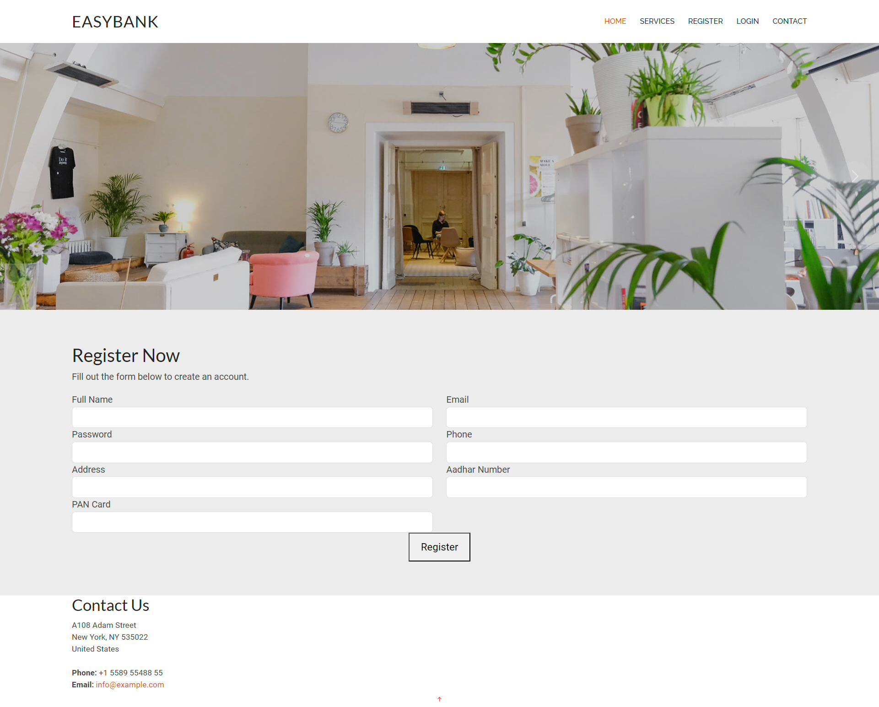

**BALANCE :**

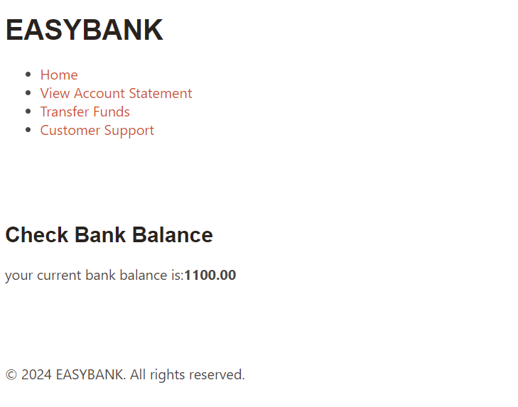

**DASHBOARD :**

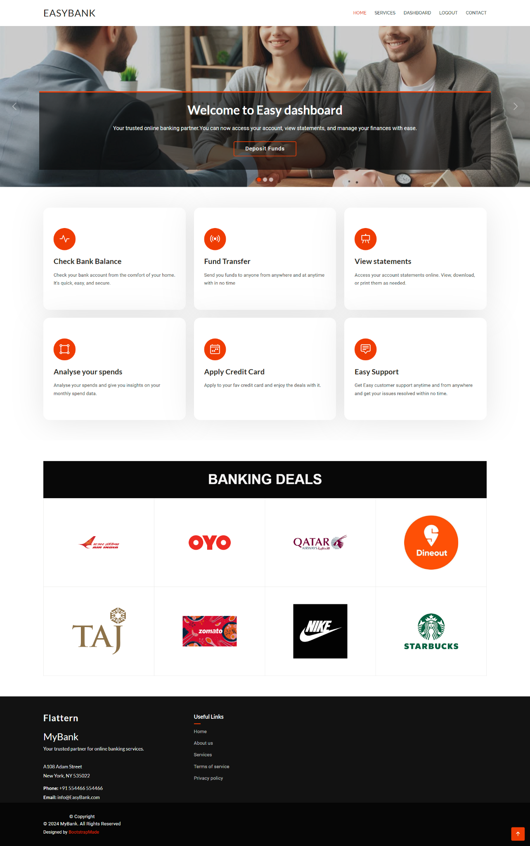

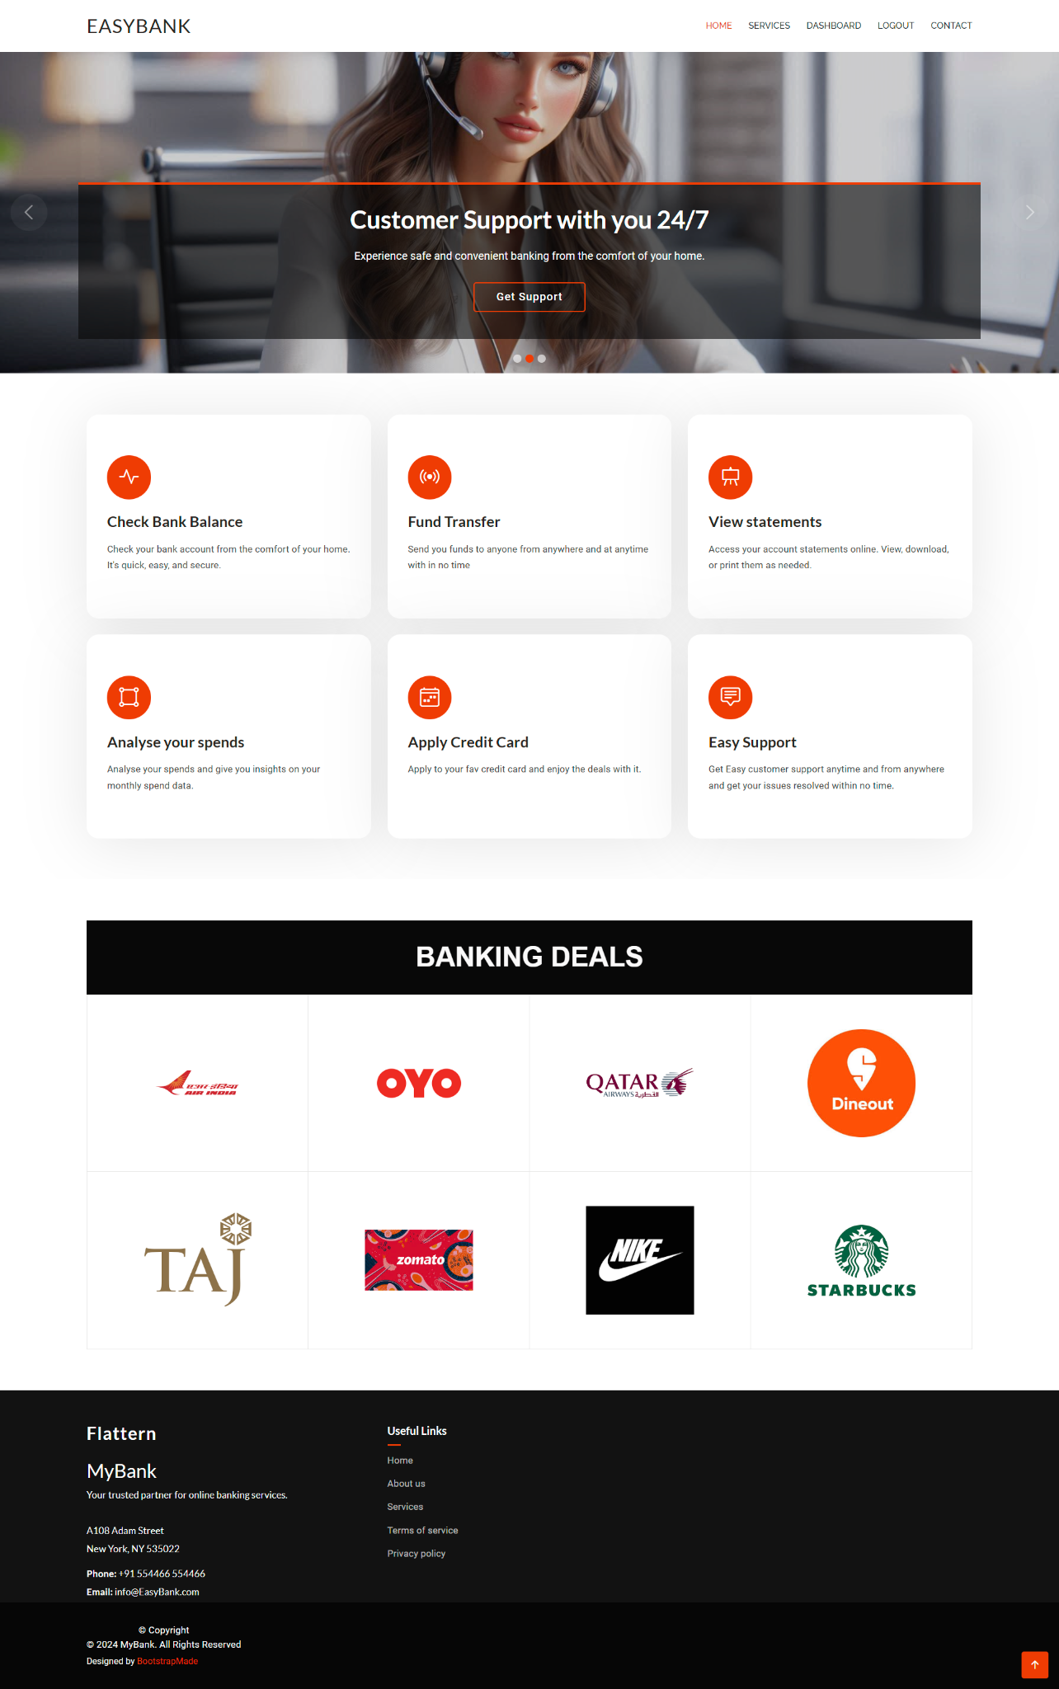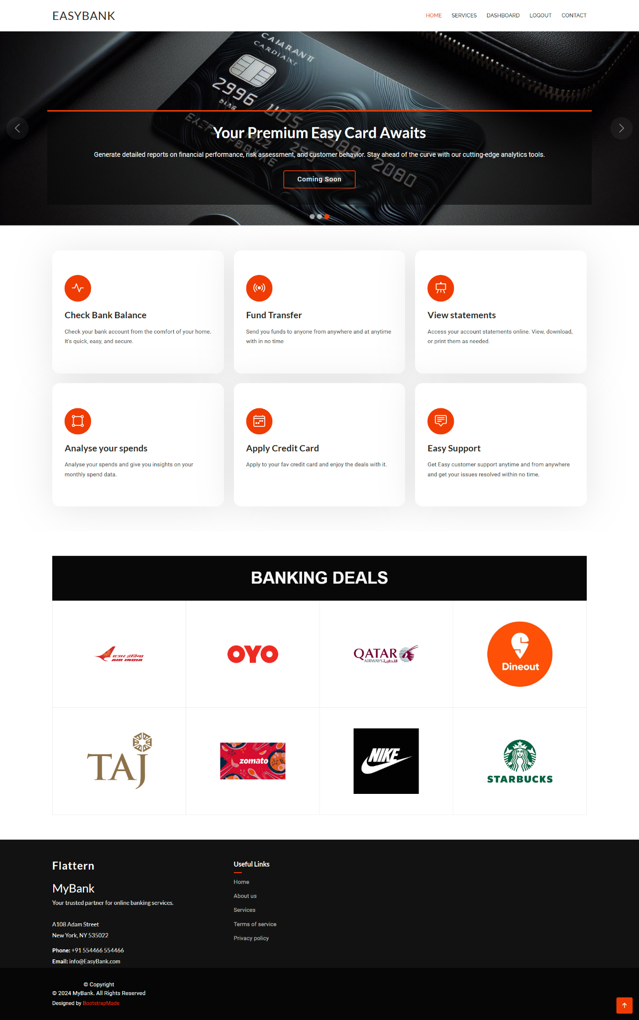

**STATEMENTS :**

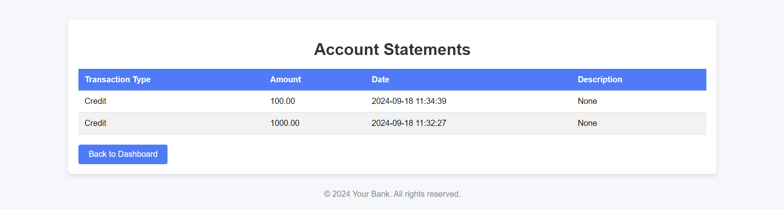

**CONTACT :**

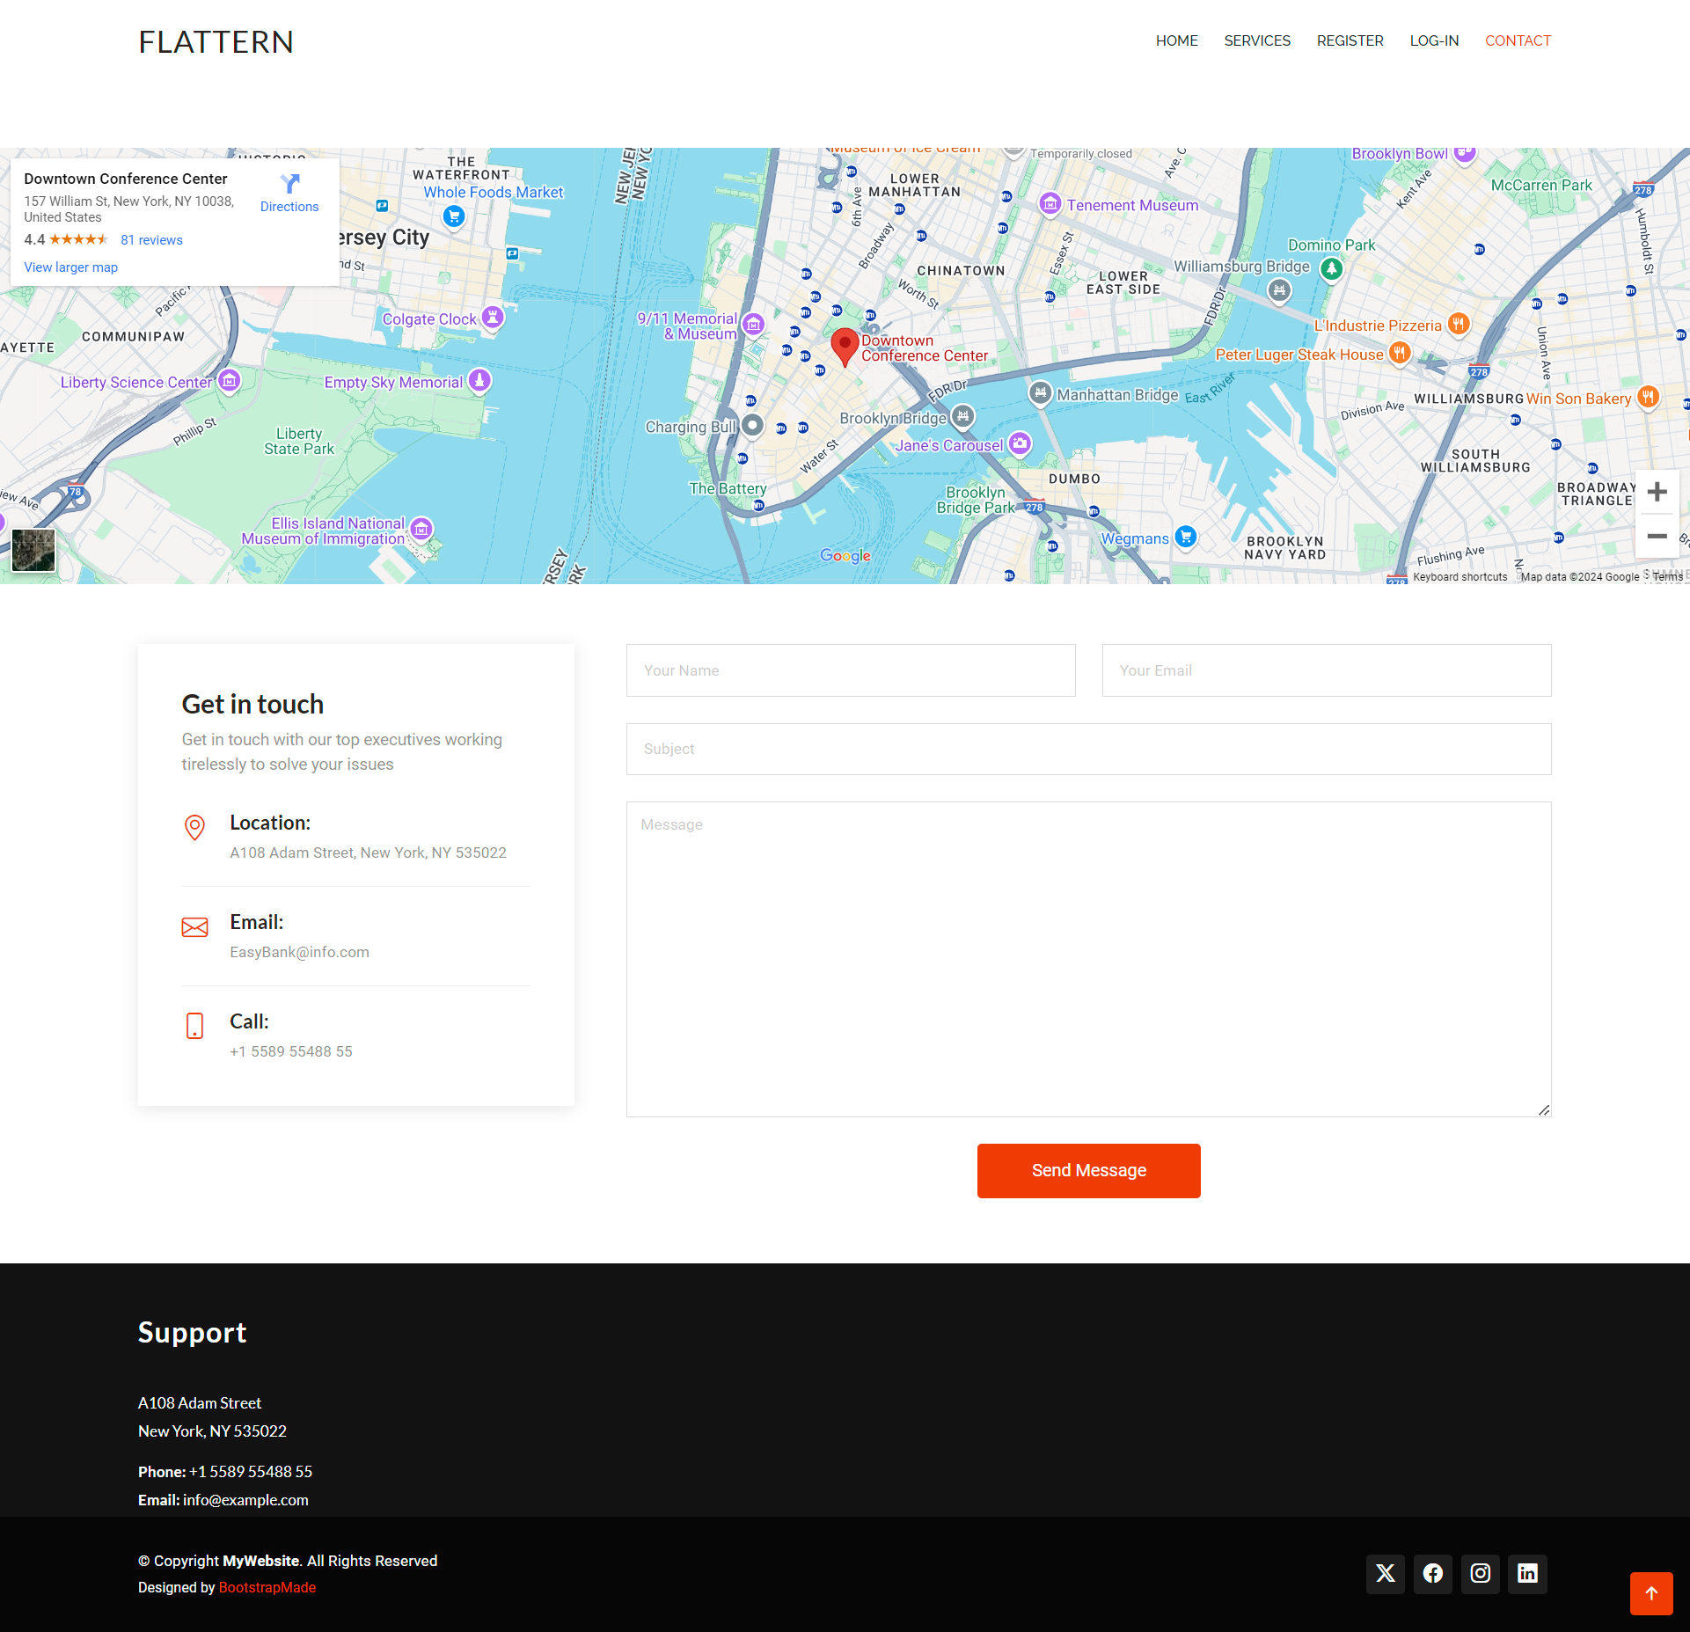

**DEPOSIT :**

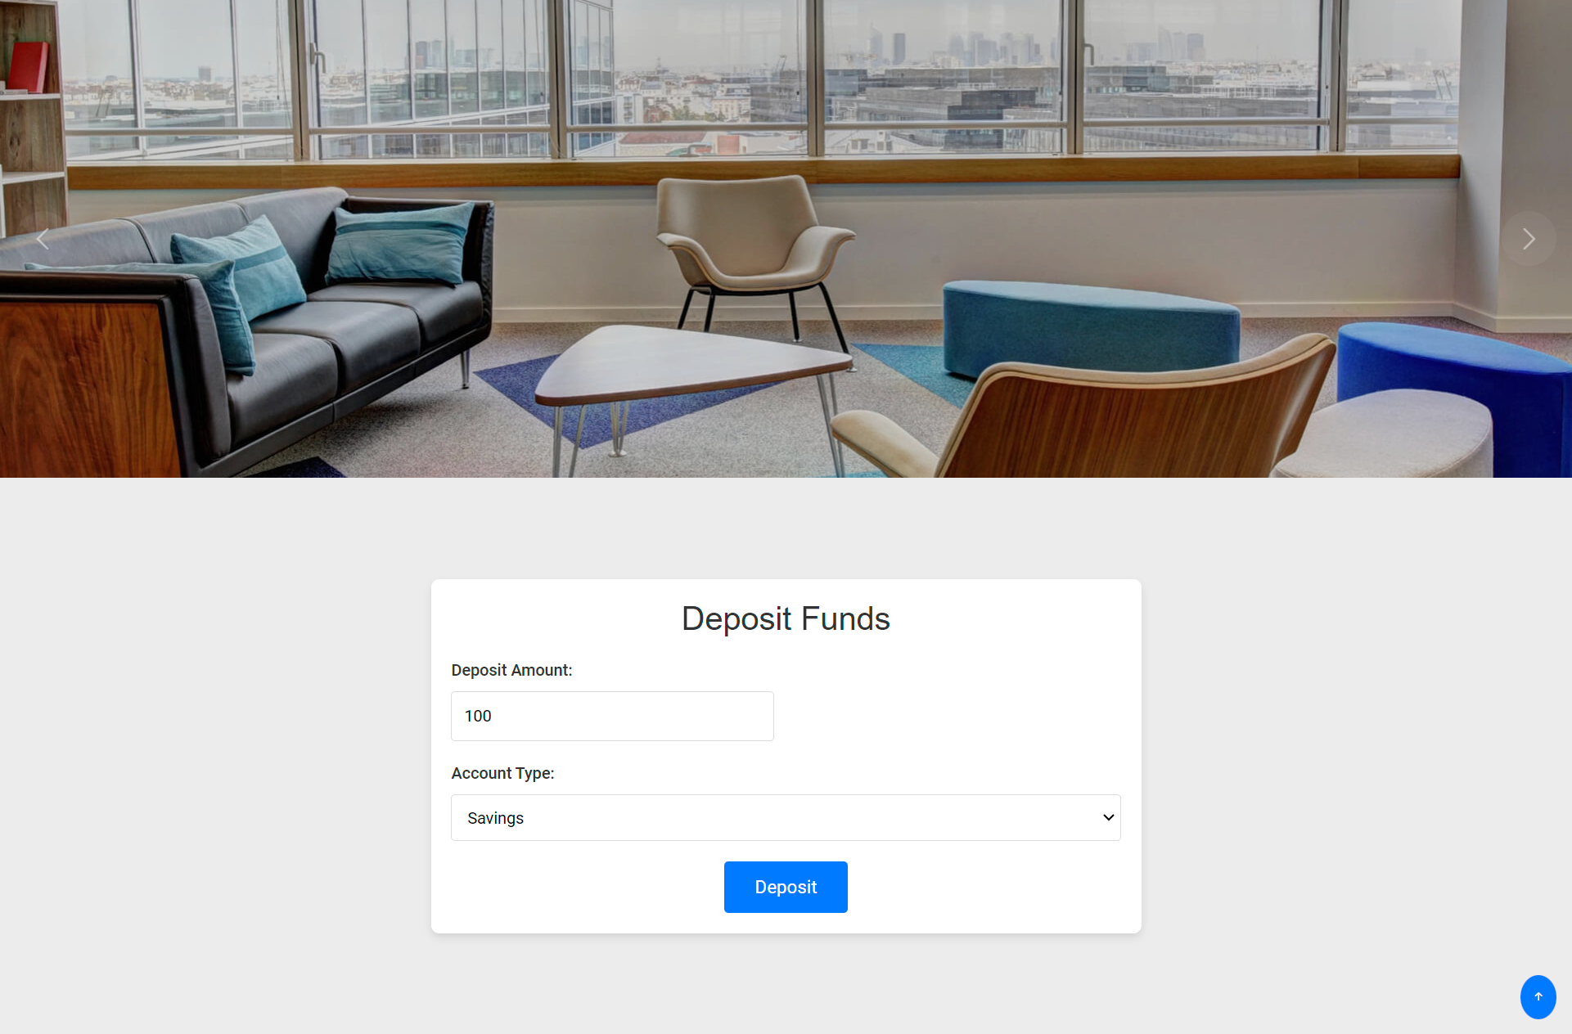

**CONFIRM :**

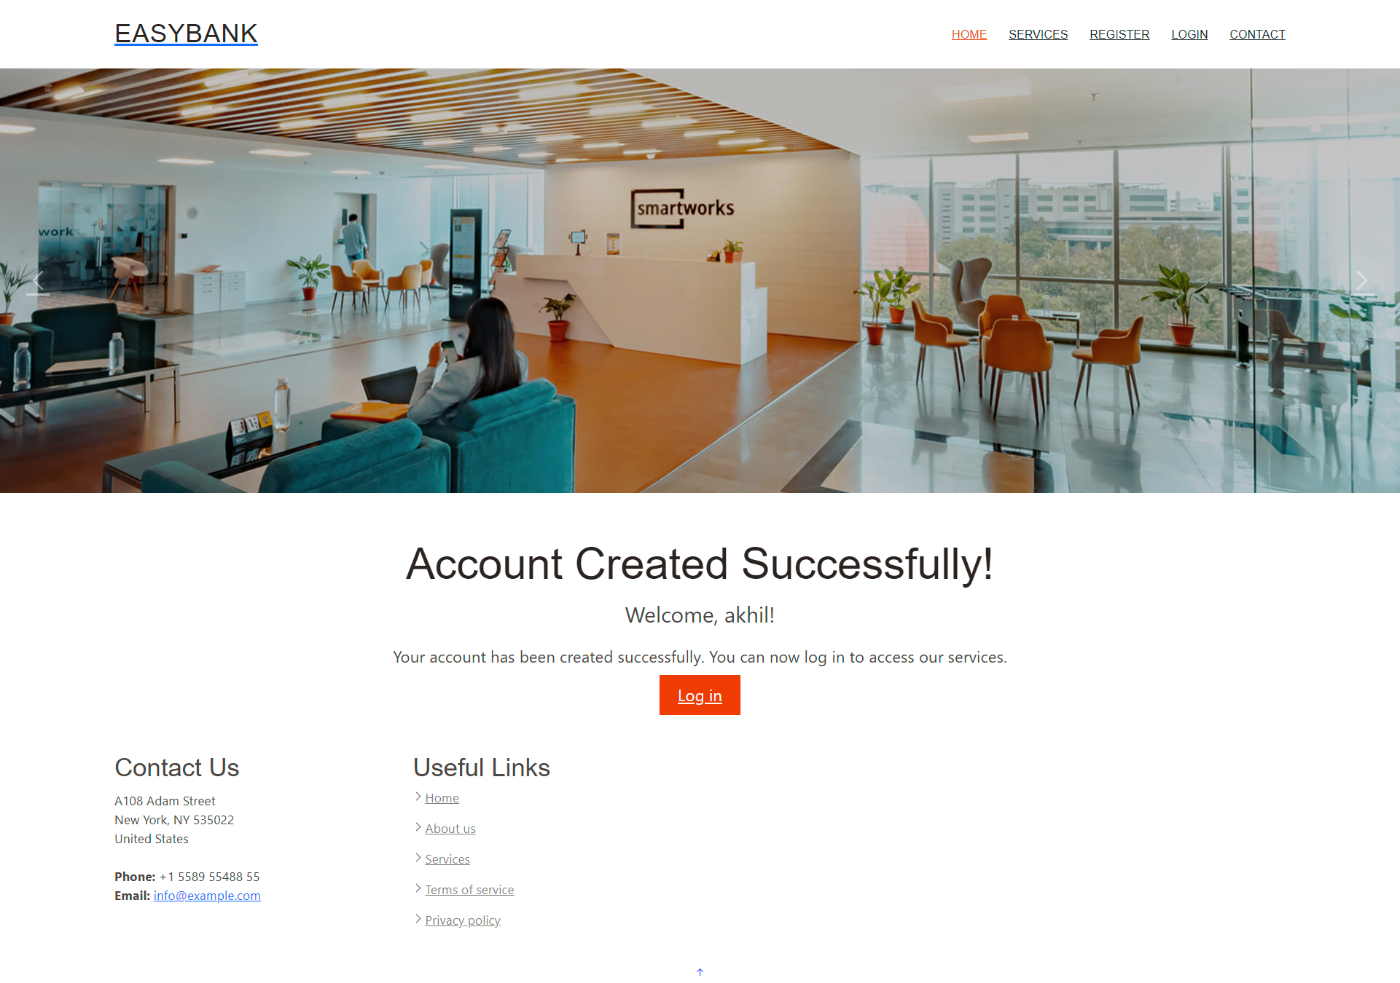

**TRANSFER :**

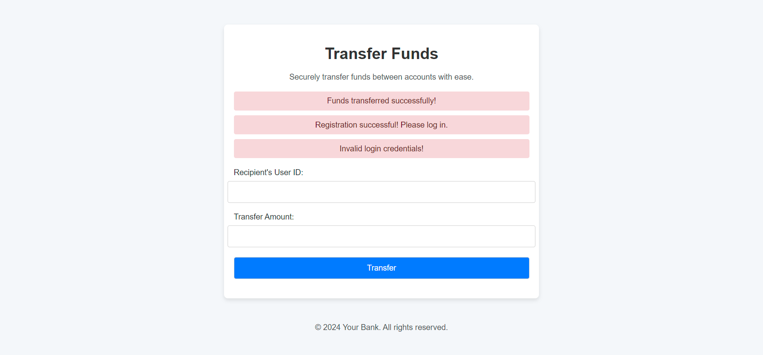

**CONCLUSION:**

The Easybank project serves as a robust foundation for a cloud-based banking system. By leveraging AWS services, we've created a scalable, secure, and efficient platform that can adapt to the evolving needs of modern banking. This project not only demonstrates technical proficiency in cloud technologies but also highlights the complexities and considerations involved in developing financial applications in the cloud.

As the financial sector continues to embrace digital transformation, projects like Easybank pave the way for more innovative, secure, and user-friendly banking solutions. The lessons learned and the architecture developed here can serve as a valuable reference for future fintech projects and cloud-based applications in sensitive domains.